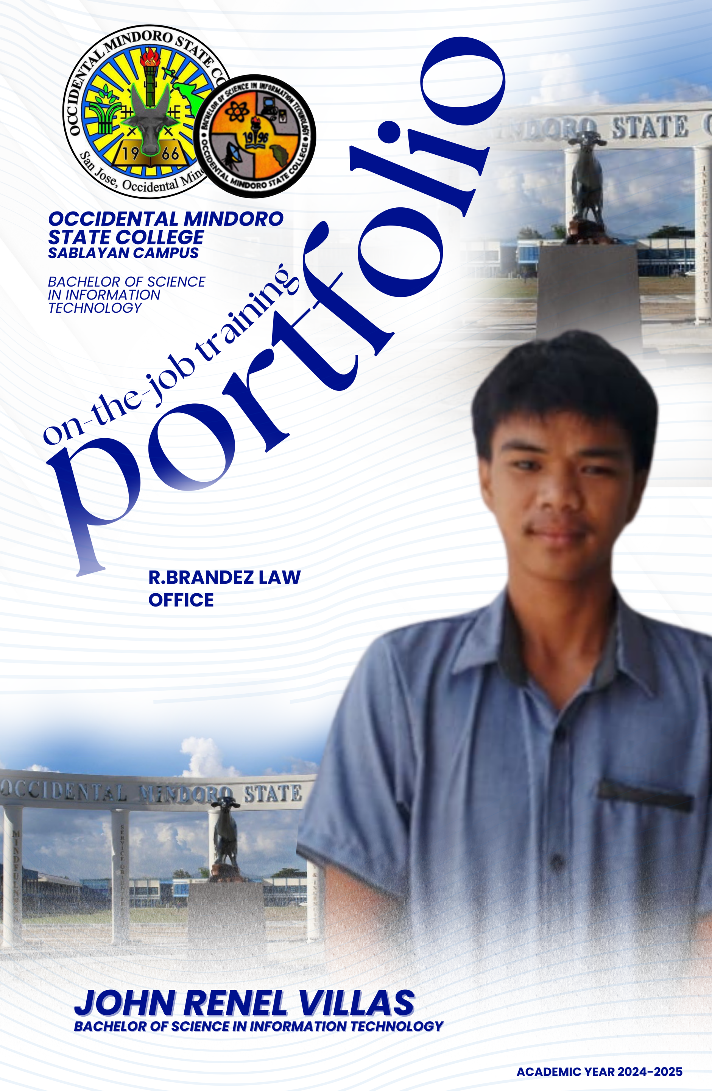

Republic of the Philippines

**OCCIDENTAL MINDORO STATE COLLEGE**

**COLLEGE OF ARTS, OF SCIENCES AND TECHNOLOGY**

**BACHELOR OF SCIENCE IN INFORMATION TECHNOLOGY**

Sablayan, Occidental Mindoro

Website: [www.omsc.edu](http://www.omsc.edu).ph Email address:omsc\_9747@gmail.com

Tele/fax: (043) 457-0231

**A NARRATIVE REPORT ON THE JOB TRAINING UNDERTAKEN AT**

**(OCCIDENTAL MINDORO STATE COLLEGE)**

A Report Submitted to the

**Faculty of the Information Technology Department**

In Partial Fulfillment of the Requirements for the Degree

**BACHELOR OF SCIENCE IN INFORMATION TECHNOLOGY**

**VILLAS, JOHN RENEL M.**

**(2025)**

**OCCIDENTAL MINDORO STATE COLLEGE**

**VISION, MISSION, THE INFORMATION TECHNOLOGY DEPARTMENT GOALS AND OBJECTIVES**

**VISION**

A premier higher education institution that develops globally competitive, locally responsive, innovative professionals and lifelong learners.

**MISSION**

Occidental Mindoro State College is committed to produce intellectual and human capital by developing excellent graduates through outcomes-based instruction, relevant research, responsive technical advisory services, community engagement and sustainable production.

**THE GOALS OF INFORMATION TECHNOLOGY DEPARTMENT**

The College of Arts, Science, and Technology aims to provide excellent education to students equipped with necessary knowledge and skills in their specialized profession.

**THE OBJECTIVES OF INFORMATION TECHNOLOGY DEPARTMENT**

1. To develop student’s computer literacy and proficiency through hands – on training and exposure to the latest trends in Information Technology.

2. To instill among students the skills of critical thinking and mathematical analysis.

3. To inculcate personal and social values, productivity, work ethics and resourcefulness.

4. To enhance the research capabilities of the students for national development and global competitiveness.

**APPROVAL SHEET**

This narrative report attached hereto entitled “**A NARRATIVE REPORT ON ON-THE JOB TRAINING (486 hours) UNDERTAKEN AT R.BRANDEZ LAW OFFICE** prepared and submitted by **VILLAS, JOHN RENEL M.** In partial fulfillment of the requirements for the degree BACHELOR OF SCIENCE IN INFORMATION TECHNOLOGY, is hereby approved and accepted.

**AILAH CHESKA F. FERNANDEZ, MIT**

OJT Coordinator

\_\_\_\_\_\_\_\_\_\_\_\_\_\_\_\_\_\_\_\_\_\_\_\_\_\_

**Date**

Approved and accepted in partial fulfillment of the requirements for the degree

**BACHELOR OF SCIENCE IN INFORMATION TECHNOLOGY (BSIT).**

**AILAH CHESKA F. FERNANDEZ, MIT**

Information Technology Department Program Chair

**\_\_\_\_\_\_\_\_\_\_\_\_\_\_\_\_\_\_\_\_\_\_\_\_**

**Date**

**ACKNOWLEDGEMENT**

I would like to express my greatest appreciation

to all those who guided me to complete

this 486 hours of On-the-Job Training (OJT).

First and foremost, I am deeply grateful to Almighty God

for providing me with strength,

perseverance, and wisdom throughout this journey.

I would like to extend my heartfelt thanks to my parents

for their unwavering support, encouragement,

and understanding, which have been invaluable to my success.

Special thanks to our OJT Coordinator, Ms. Ailah Cheska F. Fernandez,

for his continuous guidance, mentorship, and support.

His dedication and commitment have been instrumental

in my learning and development during this training period.

Lastly, I would like to express my sincere gratitude to the R.Brandez Law Office

for allowing me to conduct my OJT at their organization.

The experience has not only provided me with practical skills

and knowledge about the real workplace

but also opened my eyes to the realities of life after graduation.

Thank you all for your support and contributions

to my professional growth and development.

**VILLAS, JOHN RENEL M.**

**DEDICATION**

To my beloved parents, **Mr. Renen and Mrs. Elvie Villas**,

whose unwavering support and boundless love

have been the cornerstone of my journey.

Your guidance and encouragement have

been instrumental in shaping who I am today.

To my dear friends, whose camaraderie and encouragement

have made every step of this journey more meaningful and enjoyable.

Your constant presence has been a source of strength and joy.

Above all, to Almighty God, whose grace and blessings

have guided me through every challenge and triumph.

Your divine presence has been my ultimate source of inspiration and hope.

This accomplishment is a testament to the love,

support, and faith that each of you has bestowed upon me.

Thank you for being my guiding light and my unwavering pillars of strength.

**J.R.M.V**

**EXECUTIVE SUMMARY**

Executive summary is a term used in business for a short document that summarizes a longer report, proposal or group of related reports in such a way that readers can rapidly become acquainted with a large body of material without having to read it all. It will usually contain a brief statement of the problem or proposal covered in the major document(s), background information, concise analysis and main conclusions. It is intended as an aid to decision making by business managers.

The executive summary contains:

* Brief information of on-the job training

On the Job Training is a part of a college curriculum that aims to train and orient students about the work and their future career. OJT is very important not only to teach students their chosen career but to show students the reality about working.

The goal of the OJT program is to place participants in occupations that will enhance their prospects for long-term employment and will ultimately permit them to become self-sufficient. OJT involves the acquisition of specific skills and employment competencies, through exposure in an actual work setting, to the processes, work tasks, tools and methods of a specific job or group of jobs.

* Short introduction about the company

Legal services play a crucial role in ensuring justice, protecting rights, and maintaining peace and order within a community. Law offices, especially in rural areas, provide essential access to legal assistance and serve as important institutions in upholding the rule of law.

**R. Brandez Law Office**, located in the heart of **Sablayan, Occidental Mindoro**, is a privately owned legal firm dedicated to providing professional and reliable legal services to the local community. Headed by **Atty. R. Brandez**, the office offers a wide range of services including legal consultations, notarial services, legal documentation, and representation in court proceedings.

The law office is known for its commitment to serving clients with integrity, fairness, and respect. It caters to the needs of individuals, families, and even small businesses seeking legal guidance in matters such as land disputes, family law, civil and criminal cases, and other legal concerns.

In addition to its day-to-day operations, R. Brandez Law Office actively supports local events and initiatives in Sablayan, showing its deep involvement in the community’s progress and welfare. The firm is respected not only for its legal expertise but also for its ethical standards and dedication to justice.

Despite the challenges that come with legal practice in a developing municipality, R. Brandez Law Office continues to provide dependable and quality legal assistance, helping to uplift the lives of many Sablayanons by giving them access to the law and a voice in the justice system.

* Department/Division

I was assigned at the R.Brandez Law Office.

* Personnel in charge

Atty. Ricardo Brandez – Lawyer

* Inclusive date of training

February 20, 2025 – June 06, 2025

* Areas of training include the summary of routinely activities

During my On-the-Job Training (OJT) at **R. Brandez Law Office** in Sablayan, Occidental Mindoro, I was primarily assigned to assist with **notarial processing and document preparation**, where I applied my IT skills in supporting legal documentation and daily operations.

A significant part of my routine involved **preparing, formatting, and organizing documents** for notarization. This included affidavits, certifications, special powers of attorney, and other legal forms. I ensured that all client information was properly typed, aligned, and saved digitally for office records. I also handled **file conversions** (e.g., Word to PDF) and printed final copies ready for signing and sealing.

I maintained a **digital record system** for notarized documents, categorizing them by date and type for easy retrieval and reference. This helped improve the efficiency of the office’s documentation tracking, especially when retrieving records for repeat clients or legal follow-ups.

In support of the notarial process, I also assisted in **organizing client logs**, including names, document types, and official receipt numbers. This task required accuracy and confidentiality, as it involved handling sensitive legal information.

Through these daily activities, I strengthened my attention to detail, understanding of legal document flow, and skills in using computer tools like Microsoft Word and Excel in a legal setting. My training at R. Brandez Law Office gave me valuable experience in applying IT in a notarial environment, where precision, organization, and professionalism are essential.

* General recommendation

I would highly recommend **R. Brandez Law Office** in Sablayan, Occidental Mindoro, as an excellent OJT venue for Information Technology students. The experience provides a strong foundation in applying IT skills in a professional, real-world legal environment, particularly in support of notarial and administrative operations.

One of the most valuable aspects of my OJT was assisting in the **preparation and handling of legal and notarial documents**. This task required precision and attention to detail, skills that are essential in both IT and legal support work. I was able to apply my knowledge in formatting, file management, and document tracking in a setting where accuracy and confidentiality are critical.

The law office also gave me the opportunity to use **Microsoft Office tools effectively**, convert and manage digital files, and maintain an organized digital record system for notarized documents. These real-world applications helped me develop technical proficiency while understanding how IT supports professional service workflows.

The working environment at R. Brandez Law Office was professional yet welcoming. I received proper guidance from the staff, which helped me perform my tasks confidently and efficiently. Their willingness to involve me in important tasks, rather than just minor errands allowed me to grow not only in skills but also in responsibility and professionalism.

Overall, my training at the law office gave me practical insight into how **technology can improve efficiency in legal services**, particularly in document management and client record systems. It also taught me the value of trust, confidentiality, and organization key elements in both IT and legal work.

I would recommend R. Brandez Law Office to any IT student looking for an OJT experience that is **focused, meaningful, and skill-enhancing**, especially for those interested in working with professional documentation and office systems.

**TABLE OF CONTENTS**

|  |  |
| --- | --- |
|  | Page |
| **TITLE PAGE** | i |
| **OCCIDENTAL MINDORO STATE COLLEGE VISION AND MISSION,**  **AND DEPARTMENT GOALS AND OBJECTIVES** | ii |
| **APPROVAL SHEET** | iii |
| **ACKNOWLEDGEMENT** | iv |
| **DEDICATION** | v |
| **EXECUTIVE SUMMARY** | vi |
| **TABLE OF CONTENTS** | xi |
| **VISION/MISSION/ PLEDGE OF COMMITMENT OF THE COMPANY** | xiii |
|  |  |
| **CHAPTER** | 1 |
|  |  |
| **I INTRODUCTION** | 1 |
| Organizational Chart of Sablayan Water District | 4 |
| Department/Division | 5 |
| Personal In-Charge and Designation | 5 |
| Inclusive Dates of Training | 5 |
|  |  |
|  |  |
| **II PRACTICUM TRAINING PROGRAM** |  |
| Areas of Training | 6 |
| Functions and Duties of Trainee | 6 |
|  |  |
|  |  |
| **III INTERNSHIP PROGRESS REPORT** |  |
| Daily Activities | 7 |
| Weekly Narrative Report | 56 |
|  |  |
|  |  |
| **IV SELF-ASSESSMENT** |  |
| Achievement | 64 |
| Faults | 67 |
| Personal Relations: Integrated with the Company Personnel | 68 |
| Attendance and Punctuality | 68 |
| Interest and Commitment | 69 |
|  |  |
|  |  |
| **V RECOMENDATIONS** |  |
| Potential of a Company as Training Ground | 70 |
| Assessment to the Duration of Training | 71 |
| Proposed Revisions for the Improvement of the Training Program | 72 |
| Advised to the Future Student Trainee | 73 |

**APPENDICES**

|  |  |
| --- | --- |
| 1. Resume | 74 |
| 1. Endorsement Letter | 75 |
| 1. Parent’s Consent | 76 |
| 1. Medical Certificate | 77 |
| 1. Memorandum of Agreement | 78 |
| 1. Summary of Internship Activities | 83 |
| 1. Internship Progress Report | 84 |

|  |  |
| --- | --- |
| 1. Internship Analysis Report | 85 |
| 1. Daily Time Record | 86 |
| 1. Individual Intern Evaluation | 87 |
| 1. Company Location Map | 88 |
| 1. On-the-Job Photos | 89 |
| 1. Softcopy of the Compile Documents (CD) | 90 |
| 1. Certificate of Completion | 91 |

**Vision/ Mission/ Pledge of Commitment off the Company**

**Vision**

R. Brandez Law Office envisions a community where justice is accessible, legal services are delivered with integrity, and every client is given equal opportunity to assert their rights under the law. We strive to become a trusted legal institution in Occidental Mindoro, upholding ethical standards and excellence in every legal endeavor.

**Mission**

To provide reliable, efficient, and ethical legal services to individuals and organizations by promoting the rule of law, safeguarding the rights of clients, and supporting justice through honest and professional legal representation. We are committed to delivering timely and accurate notarial services. Ensuring confidentiality and respect in handling client matters. Supporting legal education and development through collaboration, including student training and exposure.

**Pledge of Commitment**  
 As a law office committed to public service and professional growth, we pledge to, Uphold the highest standards of legal ethics and responsibility. Treat every client with fairness, honesty, and respect. Provide an environment that fosters learning, growth, and discipline for students undergoing on-the-job training. Encourage continuous improvement and support innovation through the integration of information technology in legal documentation and record-keeping.

**CHAPTER I**

**INTRODUCTION**

On-the-Job Training (OJT) is a program aimed at introducing students to various aspects of the workplace and providing hands-on training experiences that enable them to broaden their interpersonal relationships and apply the theoretical knowledge they have gained from academia. This program also helps them acquire relevant knowledge, skills, and attitudes by performing actual work related to their course of study in reputable government or non-government agencies.

The benefits of OJT include preparing future professionals for their upcoming careers, enhancing their competence and professionalism in dealing with people, and improving their critical thinking and decision-making abilities. Additionally, trainees have the opportunity to become familiar with professionals in various positions within the company.

It is essential to take OJT seriously as it requires significant effort and commitment. It can be a valuable tool for preparing for future professional endeavors and may even serve as a recommendation for their future careers.

**The Historical Background of the Company**

R. Brandez Law Office is a private legal service provider located in Sablayan, Occidental Mindoro. It was established to serve the growing legal and notarial needs of individuals, businesses, and institutions within the municipality and nearby communities. Founded by Atty. Ricardo Brandez, the office has steadily gained a reputation for offering honest, accessible, and professional legal services.

Since its founding, the law office has focused on providing assistance in civil, criminal, and administrative cases, as well as notarial services such as affidavit preparation, contracts, deeds, and other legal documentation. The office plays a vital role in the local justice system by ensuring that legal processes are understood and followed by clients from all walks of life.

Initially operating with limited resources, R. Brandez Law Office has grown through the dedication and professionalism of its team. Over time, the office upgraded its facilities and adopted modern tools and software to improve document handling, storage, and client transactions. Its strategic location in Sablayan makes it easily accessible to the public, especially those in need of legal advice and documentation.

Despite facing various challenges, including the rising number of legal concerns in the community and the adjustments required during the COVID-19 pandemic, the law office has remained consistent in delivering essential services. During the pandemic, it adopted health protocols and adjusted client scheduling to continue operations safely and efficiently.

Today, R. Brandez Law Office stands as a trusted legal partner in Sablayan, committed to upholding justice, transparency, and service to the community. It continues to adapt to changes in the legal environment and strives to assist clients in navigating the law with clarity and confidence.

**Vision/ Mission/ Quality Objectives and Quality policy of the Company**

**Vision**

R. Brandez Law Office envisions a community where justice is accessible, legal services are delivered with integrity, and every client is given equal opportunity to assert their rights under the law. We strive to become a trusted legal institution in Occidental Mindoro, upholding ethical standards and excellence in every legal endeavor.

**Mission**

To provide reliable, efficient, and ethical legal services to individuals and organizations by promoting the rule of law, safeguarding the rights of clients, and supporting justice through honest and professional legal representation. We are committed to delivering timely and accurate notarial services. Ensuring confidentiality and respect in handling client matters. Supporting legal education and development through collaboration, including student training and exposure.

**Quality Policy Statement**  
 R. Brandez Law Office is dedicated to delivering high-quality legal and notarial services guided by the principles of professionalism, integrity, and public service.  
The office ensures compliance with the laws of the Republic of the Philippines and observes ethical standards in every transaction. Committed to continuous improvement, the law office adapts to legal developments and innovations to meet the needs of its clients, while upholding justice and fairness in all aspects of its operation.

**Organizational Chart**

**R.Brandez Law Office Organizational Chart**

**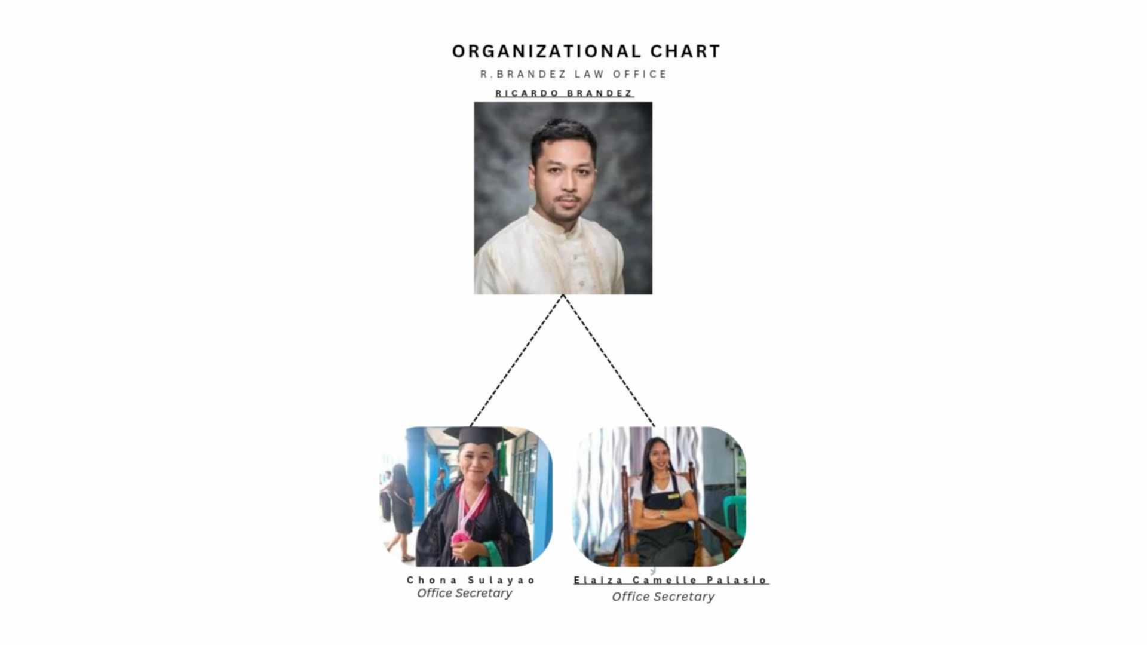**

**Department/Division/Section Assigned**

I was assigned to **R. Brandez Law Office**, located in Sablayan, Occidental Mindoro, where I assisted in legal-related clerical tasks and IT support specifically intended to help notarial documentation and client record management.

**Personnel In-charge and Designation**

Atty. **Ricardo Brandez**– Lawyer

**Inclusive Dates of Training**

The duration of training was started on February 20, 2025 up to June 06, 2025. And was completed the total hours 486 upon the requirements to be completed 486 hours of training.

**CHAPTER II**

**PRACTICUM TRAINING PROGRAM**

Occidental Mindoro State College is mandated to develop policies, systems, procedures and programs that promote strong academic linkages with business and industry for cross-cultural training and skills enhancement to make students competitive for employment in the Philippines and abroad.

Hence, Practicum Training is the application for classroom learning to actual work such as but not limited to commercial and industrial services, government and non-government agencies that will provide students the opportunity to acquire practical knowledge, skills and desirable attitudes in recognized reputable government agencies; and enhance the students’ work values, competencies, and discipline as they relate to others in different work environment.

**Areas of Training**

The area to which I was assigned is in the R.Brandez Law Office, located in Punduhan, Poblacion, Sablayan, Occidental Mindoro.

**Functions and Duties of Trainee**

My functions and duties as a trainee at **R. Brandez Law Office** included providing technical and clerical support, specifically focused on assisting in notarial documentation and digital file management. One of my key responsibilities was to help digitize and organize legal documents such as contracts, affidavits, deeds, and notarized forms to ensure they were stored securely and could be easily retrieved when needed. I also supported the preparation of client files, scanned important paperwork, and maintained backups of critical records. Part of my duty was to assist in formatting legal templates and ensuring that all documents followed proper legal structure and form. These tasks helped improve the office’s operational efficiency, minimized paperwork clutter, and promoted a more organized and technology-supported legal environment.

**CHAPTER III**

Republic of the Philippines

**OCCIDENTAL MINDORO STATE COLLEGE**

Sablayan, Occidental Mindoro

Website: [www.omsc.edu](http://www.omsc.edu).ph Email address:omsc\_9747@gmail.com

Tele/Fax: (043) 457-0231

**Bachelor of Science in Information Technology**

**DAILY NARRATIVE REPORT**

February 20, 2025

Office Assignment: **R.Brandez Law Office**

Office Address: **Punduhan, Poblacion, Sablayan, Occidental Mindoro**

On my first day of on-the-job training (OJT) at Brandez Law Office, I was formally introduced to Atty. Brandez by our OJT coordinator. The introduction served as an official start to the training program and helped establish a professional connection with the supervising attorney. After the introduction, I was given a brief orientation regarding the office rules, daily routines, and the expectations from student trainees. I also became familiar with the work environment, including the layout of the office, the staff members, and the general procedures followed in handling legal documents and clients. This initial orientation provided me with a clear understanding of my role and helped me prepare for the tasks and responsibilities I would be handling throughout my training.

Prepared and Accomplished by:

**JOHN RENEL M. VILLAS**

Student Trainee

Noted:

**ATTY. RICARDO BRANDEZ**

Owner/Lawyer

Republic of the Philippines

**OCCIDENTAL MINDORO STATE COLLEGE**

Sablayan, Occidental Mindoro

Website: [www.omsc.edu](http://www.omsc.edu).ph Email address:omsc\_9747@gmail.com

Tele/Fax: (043) 457-0231

**Bachelor of Science in Information Technology**

**DAILY NARRATIVE REPORT**

February 24, 2025

Office Assignment: **R.Brandez Law Office**

Office Address: **Punduhan, Poblacion, Sablayan, Occidental Mindoro**

On the second day of my On-the-Job Training, I cleaned the office of the R. BRANDEZ LAW OFFICE.

I completed all of the tasks assigned to me, and at 12 p.m., I went out to eat lunch to regain my energy so that I could notarize documents again. After I finished eating, I walked to the R. BRANDEZ LAW OFFICE at exactly 1 p.m. I continued with my remaining task.

Prepared and Accomplished by:

**JOHN RENEL M. VILLAS**

Student Trainee

Noted:

**ATTY. RICARDO BRANDEZ**

Owner/Lawyer

Republic of the Philippines

**OCCIDENTAL MINDORO STATE COLLEGE**

Sablayan, Occidental Mindoro

Website: [www.omsc.edu](http://www.omsc.edu).ph Email address:omsc\_9747@gmail.com

Tele/Fax: (043) 457-0231

**Bachelor of Science in Information Technology**

**DAILY NARRATIVE REPORT**

February 25, 2025

Office Assignment: **R.Brandez Law Office**

Office Address: **Punduhan, Poblacion, Sablayan, Occidental Mindoro**

On my third day, February 25, 2025, I woke up early so I could cook my breakfast. After eating, I took a shower to get in. And before 8 o'clock, I was in the office, and the first thing I did was sweep and mop the floor. I completed all of the tasks assigned to me, and at 12 p.m., I went out to eat lunch to regain my energy so that I could notarize documents again. After I finished eating, I walked to the R. BRANDEZ LAW OFFICE at exactly 1 p.m. I continued with my remaining task.

Prepared and Accomplished by:

**JOHN RENEL M. VILLAS**

Student Trainee

Noted:

**ATTY. RICARDO BRANDEZ**

Owner/Lawyer

Republic of the Philippines

**OCCIDENTAL MINDORO STATE COLLEGE**

Sablayan, Occidental Mindoro

Website: [www.omsc.edu](http://www.omsc.edu).ph Email address:omsc\_9747@gmail.com

Tele/Fax: (043) 457-0231

**Bachelor of Science in Information Technology**

**DAILY NARRATIVE REPORT**

February 26, 2025

Office Assignment: **R.Brandez Law Office**

Office Address: **Punduhan, Poblacion, Sablayan, Occidental Mindoro**

After finishing my initial task, I went in early on the fourth day to clean and mop. Atty. Ricardo Brandez informed us that we would be taken to the central sub prison to notarize, and that once we completed in the central sub prison, we would proceed to the Pasugui sub prison to notarize as well. And once we finished notarizing, we returned to the office, which marked the end of my fourth day on OJT.

Prepared and Accomplished by:

**JOHN RENEL M. VILLAS**

Student Trainee

Noted:

**ATTY. RICARDO BRANDEZ**

Owner/Lawyer

Republic of the Philippines

**OCCIDENTAL MINDORO STATE COLLEGE**

Sablayan, Occidental Mindoro

Website: [www.omsc.edu](http://www.omsc.edu).ph Email address:omsc\_9747@gmail.com

Tele/Fax: (043) 457-0231

**Bachelor of Science in Information Technology**

**DAILY NARRATIVE REPORT**

February 27, 2025

Office Assignment: **R.Brandez Law Office**

Office Address: **Punduhan, Poblacion, Sablayan, Occidental Mindoro**

On my fifth day of OJT, I did exactly what I had done on my first day. I swept and mopped. After I finished cleaning, I completed the notary task. After the notary task, we eating snacks and talked with our beautiful sisters, Chona and Camille.

Prepared and Accomplished by:

**JOHN RENEL M. VILLAS**

Student Trainee

Noted:

**ATTY. RICARDO BRANDEZ**

Owner/Lawyer

Republic of the Philippines

**OCCIDENTAL MINDORO STATE COLLEGE**

Sablayan, Occidental Mindoro

Website: [www.omsc.edu](http://www.omsc.edu).ph Email address:omsc\_9747@gmail.com

Tele/Fax: (043) 457-0231

**Bachelor of Science in Information Technology**

**DAILY NARRATIVE REPORT**

February 28, 2025

Office Assignment: **R.Brandez Law Office**

Office Address: **Punduhan, Poblacion, Sablayan, Occidental Mindoro**

On February 28, I continued my on-the-job training at Brandez Law Office by observing the notarial process. I assisted in organizing documents for clients and learned how to properly arrange and verify paperwork before notarization. I also observed how Atty. Brandez reviews and signs the documents, and how the notarial logbook is maintained for record-keeping. This helped me understand the importance of accuracy and legality in official document handling.

Prepared and Accomplished by:

**JOHN RENEL M. VILLAS**

Student Trainee

Noted:

**ATTY. RICARDO BRANDEZ**

Owner/Lawyer

Republic of the Philippines

**OCCIDENTAL MINDORO STATE COLLEGE**

Sablayan, Occidental Mindoro

Website: [www.omsc.edu](http://www.omsc.edu).ph Email address:omsc\_9747@gmail.com

Tele/Fax: (043) 457-0231

**Bachelor of Science in Information Technology**

**DAILY NARRATIVE REPORT**

March 1, 2025

Office Assignment: **R.Brandez Law Office**

Office Address: **Punduhan, Poblacion, Sablayan, Occidental Mindoro**

Today at Brandez Law Office, I began the day by helping clean and organize the office to ensure a neat and professional working environment. I assisted in arranging documents, wiping down tables, and maintaining the general tidiness of the workplace. During less busy hours, I had the opportunity to converse with my fellow OJT trainees. We shared experiences and insights about our tasks, which helped strengthen our teamwork and made the training atmosphere more enjoyable and collaborative.

Prepared and Accomplished by:

**JOHN RENEL M. VILLAS**

Student Trainee

Noted:

**ATTY. RICARDO BRANDEZ**

Owner/Lawyer

Republic of the Philippines

**OCCIDENTAL MINDORO STATE COLLEGE**

Sablayan, Occidental Mindoro

Website: [www.omsc.edu](http://www.omsc.edu).ph Email address:omsc\_9747@gmail.com

Tele/Fax: (043) 457-0231

**Bachelor of Science in Information Technology**

**DAILY NARRATIVE REPORT**

March 3, 2025

Office Assignment: **R.Brandez Law Office**

Office Address: **Punduhan, Poblacion, Sablayan, Occidental Mindoro**

On this day at Brandez Law Office, I was tasked with sorting and arranging legal documents in their proper folders. I ensured that each file was organized according to its category for easier access by the attorney and staff. While doing this, I observed how legal papers are handled and stored properly to maintain confidentiality and order. I also continued to familiarize myself with some basic legal terms used in notarial documents, helping me slowly build my knowledge about law office operations.

Prepared and Accomplished by:

**JOHN RENEL M. VILLAS**

Student Trainee

Noted:

**ATTY. RICARDO BRANDEZ**

Owner/Lawyer

Republic of the Philippines

**OCCIDENTAL MINDORO STATE COLLEGE**

Sablayan, Occidental Mindoro

Website: [www.omsc.edu](http://www.omsc.edu).ph Email address:omsc\_9747@gmail.com

Tele/Fax: (043) 457-0231

**Bachelor of Science in Information Technology**

**DAILY NARRATIVE REPORT**

March 4, 2025

Office Assignment: **R.Brandez Law Office**

Office Address: **Punduhan, Poblacion, Sablayan, Occidental Mindoro**

Today was a relatively quiet day at Brandez Law Office. There were no assigned tasks for me in the morning, so I mostly observed the office operations and how clients were assisted. I also spent some time reading through old notarial documents to familiarize myself with their format. It was a light but still informative day that allowed me to better understand the typical workflow in a legal setting.

Prepared and Accomplished by:

**JOHN RENEL M. VILLAS**

Student Trainee

Noted:

**ATTY. RICARDO BRANDEZ**

Owner/Lawyer

Republic of the Philippines

**OCCIDENTAL MINDORO STATE COLLEGE**

Sablayan, Occidental Mindoro

Website: [www.omsc.edu](http://www.omsc.edu).ph Email address:omsc\_9747@gmail.com

Tele/Fax: (043) 457-0231

**Bachelor of Science in Information Technology**

**DAILY NARRATIVE REPORT**

March 5, 2025

Office Assignment: **R.Brandez Law Office**

Office Address: **Punduhan, Poblacion, Sablayan, Occidental Mindoro**

Since today is Ash Wednesday, our time at Brandez Law Office was shortened. We only stayed for a few hours in the morning. There were no major tasks assigned, but we helped in organizing some folders and cleaning the work area. Afterward, we were allowed to go home early to observe the religious occasion. It was a light and respectful day at the office.

Prepared and Accomplished by:

**JOHN RENEL M. VILLAS**

Student Trainee

Noted:

**ATTY. RICARDO BRANDEZ**

Owner/Lawyer

Republic of the Philippines

**OCCIDENTAL MINDORO STATE COLLEGE**

Sablayan, Occidental Mindoro

Website: [www.omsc.edu](http://www.omsc.edu).ph Email address:omsc\_9747@gmail.com

Tele/Fax: (043) 457-0231

**Bachelor of Science in Information Technology**

**DAILY NARRATIVE REPORT**

March 6, 2025

Office Assignment: **R.Brandez Law Office**

Office Address: **Punduhan, Poblacion, Sablayan, Occidental Mindoro**

Today at Brandez Law Office, we resumed regular tasks. I assisted in organizing legal documents and updating some folders for better filing. We also observed how the staff accommodated walk-in clients, which gave us a better understanding of proper client handling and maintaining professionalism. I learned how to properly sort notarized papers and prepare them for archiving. It was a productive day with hands-on experience.

Prepared and Accomplished by:

**JOHN RENEL M. VILLAS**

Student Trainee

Noted:

**ATTY. RICARDO BRANDEZ**

Owner/Lawyer

Republic of the Philippines

**OCCIDENTAL MINDORO STATE COLLEGE**

Sablayan, Occidental Mindoro

Website: [www.omsc.edu](http://www.omsc.edu).ph Email address:omsc\_9747@gmail.com

Tele/Fax: (043) 457-0231

**Bachelor of Science in Information Technology**

**DAILY NARRATIVE REPORT**

March 7, 2025

Office Assignment: **R.Brandez Law Office**

Office Address: **Punduhan, Poblacion, Sablayan, Occidental Mindoro**

Today at Brandez Law Office, I focused on sorting and arranging previously notarized documents. I also helped in checking if all pages were properly stamped and signed. During the quieter moments, I cleaned the workspace and assisted in maintaining order in the filing cabinet. Although the workload was manageable, I still made sure to stay attentive and ready to help with any tasks assigned.

Prepared and Accomplished by:

**JOHN RENEL M. VILLAS**

Student Trainee

Noted:

**ATTY. RICARDO BRANDEZ**

Owner/Lawyer

Republic of the Philippines

**OCCIDENTAL MINDORO STATE COLLEGE**

Sablayan, Occidental Mindoro

Website: [www.omsc.edu](http://www.omsc.edu).ph Email address:omsc\_9747@gmail.com

Tele/Fax: (043) 457-0231

**Bachelor of Science in Information Technology**

**DAILY NARRATIVE REPORT**

March 8, 2025

Office Assignment: **R.Brandez Law Office**

Office Address: **Punduhan, Poblacion, Sablayan, Occidental Mindoro**

Today was a relatively light day at Brandez Law Office. There were no clients in the morning, so I took the time to clean the office, wipe desks, and organize supplies. I also chatted briefly with fellow OJTs about our experiences so far. Although there weren’t many tasks, I remained available in case any assistance was needed.

Prepared and Accomplished by:

**JOHN RENEL M. VILLAS**

Student Trainee

Noted:

**ATTY. RICARDO BRANDEZ**

Owner/Lawyer

Republic of the Philippines

**OCCIDENTAL MINDORO STATE COLLEGE**

Sablayan, Occidental Mindoro

Website: [www.omsc.edu](http://www.omsc.edu).ph Email address:omsc\_9747@gmail.com

Tele/Fax: (043) 457-0231

**Bachelor of Science in Information Technology**

**DAILY NARRATIVE REPORT**

March 10, 2025

Office Assignment: **R.Brandez Law Office**

Office Address: **Punduhan, Poblacion, Sablayan, Occidental Mindoro**

Today at Brandez Law Office, I assisted in sorting and organizing some legal documents that were used in past cases. This helped me become more familiar with how case files are arranged and labeled. In the afternoon, I observed Atty. Brandez discussing legal matters with a client, which gave me insight into professional client handling and legal consultation. It was a productive and educational day.

Prepared and Accomplished by:

**JOHN RENEL M. VILLAS**

Student Trainee

Noted:

**ATTY. RICARDO BRANDEZ**

Owner/Lawyer

Republic of the Philippines

**OCCIDENTAL MINDORO STATE COLLEGE**

Sablayan, Occidental Mindoro

Website: [www.omsc.edu](http://www.omsc.edu).ph Email address:omsc\_9747@gmail.com

Tele/Fax: (043) 457-0231

**Bachelor of Science in Information Technology**

**DAILY NARRATIVE REPORT**

March 10, 2025

Office Assignment: **R.Brandez Law Office**

Office Address: **Punduhan, Poblacion, Sablayan, Occidental Mindoro**

Today at Brandez Law Office, I assisted in sorting and organizing some legal documents that were used in past cases. This helped me become more familiar with how case files are arranged and labeled. In the afternoon, I observed Atty. Brandez discussing legal matters with a client, which gave me insight into professional client handling and legal consultation. It was a productive and educational day.

Prepared and Accomplished by:

**JOHN RENEL M. VILLAS**

Student Trainee

Noted:

**ATTY. RICARDO BRANDEZ**

Owner/Lawyer

Republic of the Philippines

**OCCIDENTAL MINDORO STATE COLLEGE**

Sablayan, Occidental Mindoro

Website: [www.omsc.edu](http://www.omsc.edu).ph Email address:omsc\_9747@gmail.com

Tele/Fax: (043) 457-0231

**Bachelor of Science in Information Technology**

**DAILY NARRATIVE REPORT**

March 11, 2025

Office Assignment: **R.Brandez Law Office**

Office Address: **Punduhan, Poblacion, Sablayan, Occidental Mindoro**

Today was a relatively quiet day at Brandez Law Office. There were no major activities, but I spent time reviewing various legal forms and documents, such as affidavits and notarial templates. This helped me become more familiar with the format and language commonly used in legal writing. I also assisted in minor tasks like photocopying and organizing some files on the desk.

Prepared and Accomplished by:

**JOHN RENEL M. VILLAS**

Student Trainee

Noted:

**ATTY. RICARDO BRANDEZ**

Owner/Lawyer

Republic of the Philippines

**OCCIDENTAL MINDORO STATE COLLEGE**

Sablayan, Occidental Mindoro

Website: [www.omsc.edu](http://www.omsc.edu).ph Email address:omsc\_9747@gmail.com

Tele/Fax: (043) 457-0231

**Bachelor of Science in Information Technology**

**DAILY NARRATIVE REPORT**

March 12, 2025

Office Assignment: **R.Brandez Law Office**

Office Address: **Punduhan, Poblacion, Sablayan, Occidental Mindoro**

Today, I assisted in organizing case folders and updating some of the document labels at Brandez Law Office. It was a good opportunity to better understand how legal files are arranged and maintained. During breaks, I also had conversations with my fellow OJT companions about our experiences so far. Sharing insights and stories helped build a more comfortable and supportive environment in the office.

Prepared and Accomplished by:

**JOHN RENEL M. VILLAS**

Student Trainee

Noted:

**ATTY. RICARDO BRANDEZ**

Owner/Lawyer

Republic of the Philippines

**OCCIDENTAL MINDORO STATE COLLEGE**

Sablayan, Occidental Mindoro

Website: [www.omsc.edu](http://www.omsc.edu).ph Email address:omsc\_9747@gmail.com

Tele/Fax: (043) 457-0231

**Bachelor of Science in Information Technology**

**DAILY NARRATIVE REPORT**

March 13, 2025

Office Assignment: **R.Brandez Law Office**

Office Address: **Punduhan, Poblacion, Sablayan, Occidental Mindoro**

Today at Brandez Law Office, I assisted in sorting and organizing legal documents for upcoming appointments. I helped in preparing the notarial logbook and arranging client folders to ensure everything was in order. During the afternoon, I also helped clean and tidy up the reception area. In between tasks, I had a short but meaningful conversation with a fellow OJT about how we're both adjusting to the training environment. It was a productive day with a balance of work and interaction.

Prepared and Accomplished by:

**JOHN RENEL M. VILLAS**

Student Trainee

Noted:

**ATTY. RICARDO BRANDEZ**

Owner/Lawyer

Republic of the Philippines

**OCCIDENTAL MINDORO STATE COLLEGE**

Sablayan, Occidental Mindoro

Website: [www.omsc.edu](http://www.omsc.edu).ph Email address:omsc\_9747@gmail.com

Tele/Fax: (043) 457-0231

**Bachelor of Science in Information Technology**

**DAILY NARRATIVE REPORT**

March 14, 2025

Office Assignment: **R.Brandez Law Office**

Office Address: **Punduhan, Poblacion, Sablayan, Occidental Mindoro**

Today was a productive and busy day at Brandez Law Office. I started the morning by assisting in encoding and printing legal forms needed for notarization. I also helped in arranging client appointments and answered basic inquiries under the supervision of the staff. In the afternoon, I was tasked with organizing case folders and making sure each was properly labeled and updated. I assisted in photocopying important documents and observed how the staff handled client consultations. It was fulfilling to be trusted with more responsibilities and to contribute actively to the office’s workflow.

Prepared and Accomplished by:

**JOHN RENEL M. VILLAS**

Student Trainee

Noted:

**ATTY. RICARDO BRANDEZ**

Owner/Lawyer

Republic of the Philippines

**OCCIDENTAL MINDORO STATE COLLEGE**

Sablayan, Occidental Mindoro

Website: [www.omsc.edu](http://www.omsc.edu).ph Email address:omsc\_9747@gmail.com

Tele/Fax: (043) 457-0231

**Bachelor of Science in Information Technology**

**DAILY NARRATIVE REPORT**

March 17, 2025

Office Assignment: **R.Brandez Law Office**

Office Address: **Punduhan, Poblacion, Sablayan, Occidental Mindoro**

Today at Brandez Law Office, the workload was lighter compared to previous days. I spent most of the morning sorting and arranging legal documents in their respective folders. I also checked for any unsigned papers that needed to be forwarded to Atty. Brandez. During free time, I had a brief discussion with fellow OJTs about the importance of confidentiality in handling client information. Though it was a relatively calm day, it still contributed to my understanding of the daily operations in a legal office.

Prepared and Accomplished by:

**JOHN RENEL M. VILLAS**

Student Trainee

Noted:

**ATTY. RICARDO BRANDEZ**

Owner/Lawyer

Republic of the Philippines

**OCCIDENTAL MINDORO STATE COLLEGE**

Sablayan, Occidental Mindoro

Website: [www.omsc.edu](http://www.omsc.edu).ph Email address:omsc\_9747@gmail.com

Tele/Fax: (043) 457-0231

**Bachelor of Science in Information Technology**

**DAILY NARRATIVE REPORT**

March 18, 2025

Office Assignment: **R.Brandez Law Office**

Office Address: **Punduhan, Poblacion, Sablayan, Occidental Mindoro**

Today, there were only a few clients who came in for notarization at Brandez Law Office. I assisted by preparing the necessary documents and organizing the notarial papers. With fewer tasks, I also took the time to review some office files and help maintain the cleanliness of the workspace. I had a short conversation with the staff about the importance of accuracy in legal documentation. Although the day was not very busy, it still provided valuable insight into the routine flow of a law office.

Prepared and Accomplished by:

**JOHN RENEL M. VILLAS**

Student Trainee

Noted:

**ATTY. RICARDO BRANDEZ**

Owner/Lawyer

Republic of the Philippines

**OCCIDENTAL MINDORO STATE COLLEGE**

Sablayan, Occidental Mindoro

Website: [www.omsc.edu](http://www.omsc.edu).ph Email address:omsc\_9747@gmail.com

Tele/Fax: (043) 457-0231

**Bachelor of Science in Information Technology**

**DAILY NARRATIVE REPORT**

March 19, 2025

Office Assignment: **R.Brandez Law Office**

Office Address: **Punduhan, Poblacion, Sablayan, Occidental Mindoro**

Today was a relatively quiet day at Brandez Law Office, so I spent most of my time cleaning and organizing the office. I tidied up the desks, arranged files, and ensured that all documents were properly stored. I also helped prepare some materials for upcoming notarizations and assisted in sorting out some paperwork. This allowed me to better understand the importance of maintaining an orderly workspace in a professional setting. Although there were no clients for notarization today, the day was productive in keeping the office environment clean and efficient.

Prepared and Accomplished by:

**JOHN RENEL M. VILLAS**

Student Trainee

Noted:

**ATTY. RICARDO BRANDEZ**

Owner/Lawyer

Republic of the Philippines

**OCCIDENTAL MINDORO STATE COLLEGE**

Sablayan, Occidental Mindoro

Website: [www.omsc.edu](http://www.omsc.edu).ph Email address:omsc\_9747@gmail.com

Tele/Fax: (043) 457-0231

**Bachelor of Science in Information Technology**

**DAILY NARRATIVE REPORT**

March 21, 2025

Office Assignment: **R.Brandez Law Office**

Office Address: **Punduhan, Poblacion, Sablayan, Occidental Mindoro**

Today at Brandez Law Office, I helped organize client documents and prepared files needed for upcoming notarizations. I assisted the staff by photocopying and filing important papers, ensuring everything was in order for smooth processing. There were only a few clients, so I also took the time to update some records and tidy the waiting area. Additionally, I had a short conversation with my fellow OJT trainee about our experiences so far, which made the day more engaging. Overall, it was a steady and productive day that helped me better understand the day-to-day operations of a law office.

Prepared and Accomplished by:

**JOHN RENEL M. VILLAS**

Student Trainee

Noted:

**ATTY. RICARDO BRANDEZ**

Owner/Lawyer

Republic of the Philippines

**OCCIDENTAL MINDORO STATE COLLEGE**

Sablayan, Occidental Mindoro

Website: [www.omsc.edu](http://www.omsc.edu).ph Email address:omsc\_9747@gmail.com

Tele/Fax: (043) 457-0231

**Bachelor of Science in Information Technology**

**DAILY NARRATIVE REPORT**

March 24, 2025

Office Assignment: **R.Brandez Law Office**

Office Address: **Punduhan, Poblacion, Sablayan, Occidental Mindoro**

At Brandez Law Office today, I assisted in receiving clients and helped with the initial intake of documents for notarization. Although the number of clients was manageable, I made sure to prepare all necessary forms and materials ahead of time to speed up the process. I also spent time filing and organizing legal documents to keep the office efficient. Between tasks, I chatted with other trainees and staff, which helped me learn more about the legal profession and office culture. Overall, it was a productive day that enhanced my understanding of the daily flow in a law office setting.

Prepared and Accomplished by:

**JOHN RENEL M. VILLAS**

Student Trainee

Noted:

**ATTY. RICARDO BRANDEZ**

Owner/Lawyer

Republic of the Philippines

**OCCIDENTAL MINDORO STATE COLLEGE**

Sablayan, Occidental Mindoro

Website: [www.omsc.edu](http://www.omsc.edu).ph Email address:omsc\_9747@gmail.com

Tele/Fax: (043) 457-0231

**Bachelor of Science in Information Technology**

**DAILY NARRATIVE REPORT**

March 25, 2025

Office Assignment: **R.Brandez Law Office**

Office Address: **Punduhan, Poblacion, Sablayan, Occidental Mindoro**

Today at Brandez Law Office, I focused on preparing documents for clients who requested notarization services. I carefully reviewed the paperwork to ensure completeness before submitting them to the attorney for verification. The volume of clients was moderate, which allowed me to assist more closely with the process and observe how legal documents are handled professionally. I also helped tidy up the waiting area to maintain a welcoming environment for clients. During breaks, I talked with other trainees about our experiences, which gave me insights into different areas of legal work. This day further strengthened my organizational skills and attention to detail.

Prepared and Accomplished by:

**JOHN RENEL M. VILLAS**

Student Trainee

Noted:

**ATTY. RICARDO BRANDEZ**

Owner/Lawyer

Republic of the Philippines

**OCCIDENTAL MINDORO STATE COLLEGE**

Sablayan, Occidental Mindoro

Website: [www.omsc.edu](http://www.omsc.edu).ph Email address:omsc\_9747@gmail.com

Tele/Fax: (043) 457-0231

**Bachelor of Science in Information Technology**

**DAILY NARRATIVE REPORT**

March 26, 2025

Office Assignment: **R.Brandez Law Office**

Office Address: **Punduhan, Poblacion, Sablayan, Occidental Mindoro**

Today at Brandez Law Office, the workflow was steady but not too busy. I continued assisting with the usual office tasks such as organizing files, preparing documents for notarization, and helping maintain the cleanliness of the workspace. Few clients came in for notarization, so much of the time was spent on repetitive tasks like photocopying and filing. Despite the routine nature of the work, I made sure to stay focused and efficient. I also took time to review some of the legal forms to better understand their purposes. Conversations with fellow trainees helped keep the atmosphere light and engaging during slower moments.

Prepared and Accomplished by:

**JOHN RENEL M. VILLAS**

Student Trainee

Noted:

**ATTY. RICARDO BRANDEZ**

Owner/Lawyer

Republic of the Philippines

**OCCIDENTAL MINDORO STATE COLLEGE**

Sablayan, Occidental Mindoro

Website: [www.omsc.edu](http://www.omsc.edu).ph Email address:omsc\_9747@gmail.com

Tele/Fax: (043) 457-0231

**Bachelor of Science in Information Technology**

**DAILY NARRATIVE REPORT**

March 27, 2025

Office Assignment: **R.Brandez Law Office**

Office Address: **Punduhan, Poblacion, Sablayan, Occidental Mindoro**

Today at Brandez Law Office, the workload was moderate. I assisted in preparing various legal documents and double-checked paperwork for notarization to ensure accuracy. A few clients came in for notarial services, giving me a chance to observe the procedures more closely. I also helped organize the reception area and managed incoming mail. During breaks, I chatted with other OJT trainees about our experiences and shared tips on handling tasks efficiently. Although some tasks felt repetitive, I remained attentive and eager to learn from the day’s activities.

Prepared and Accomplished by:

**JOHN RENEL M. VILLAS**

Student Trainee

Noted:

**ATTY. RICARDO BRANDEZ**

Owner/Lawyer

Republic of the Philippines

**OCCIDENTAL MINDORO STATE COLLEGE**

Sablayan, Occidental Mindoro

Website: [www.omsc.edu](http://www.omsc.edu).ph Email address:omsc\_9747@gmail.com

Tele/Fax: (043) 457-0231

**Bachelor of Science in Information Technology**

**DAILY NARRATIVE REPORT**

March 28, 2025

Office Assignment: **R.Brandez Law Office**

Office Address: **Punduhan, Poblacion, Sablayan, Occidental Mindoro**

Today’s activities at Brandez Law Office were focused on filing and organizing case files to maintain smooth office operations. I helped sort through legal documents and updated client records under the supervision of the office staff. A few clients visited for consultations and document notarization, which gave me an opportunity to observe the communication between the attorney and clients. I also assisted in keeping the waiting area clean and welcoming. Throughout the day, I remained proactive and engaged, making sure to learn as much as possible from each task.

Prepared and Accomplished by:

**JOHN RENEL M. VILLAS**

Student Trainee

Noted:

**ATTY. RICARDO BRANDEZ**

Owner/Lawyer

Republic of the Philippines

**OCCIDENTAL MINDORO STATE COLLEGE**

Sablayan, Occidental Mindoro

Website: [www.omsc.edu](http://www.omsc.edu).ph Email address:omsc\_9747@gmail.com

Tele/Fax: (043) 457-0231

**Bachelor of Science in Information Technology**

**DAILY NARRATIVE REPORT**

March 29, 2025

Office Assignment: **R.Brandez Law Office**

Office Address: **Punduhan, Poblacion, Sablayan, Occidental Mindoro**

Today, I assisted in preparing various legal documents, including affidavits and contracts, under the guidance of the staff. I also helped organize the office files and ensured that all paperwork was properly labeled for easy retrieval. There were fewer clients today, so I had the chance to observe how the attorney reviewed cases and discussed legal strategies with the team. I also spent some time tidying up the office workspace to help maintain a professional environment. Overall, it was a productive day that helped me understand more about the daily operations of a law office.

Prepared and Accomplished by:

**JOHN RENEL M. VILLAS**

Student Trainee

Noted:

**ATTY. RICARDO BRANDEZ**

Owner/Lawyer

Republic of the Philippines

**OCCIDENTAL MINDORO STATE COLLEGE**

Sablayan, Occidental Mindoro

Website: [www.omsc.edu](http://www.omsc.edu).ph Email address:omsc\_9747@gmail.com

Tele/Fax: (043) 457-0231

**Bachelor of Science in Information Technology**

**DAILY NARRATIVE REPORT**

April 2, 2025

Office Assignment: **R.Brandez Law Office**

Office Address: **Punduhan, Poblacion, Sablayan, Occidental Mindoro**

Today, I had the opportunity to observe some client consultations with Atty. Brandez, gaining insight into how legal advice is given and how cases are discussed professionally. I assisted in filing and organizing legal documents related to ongoing cases, ensuring that all paperwork was sorted properly. The office was moderately busy, so I also helped in answering phone calls and scheduling appointments. This day helped me appreciate the importance of clear communication and proper documentation in a law office setting.

Prepared and Accomplished by:

**JOHN RENEL M. VILLAS**

Student Trainee

Noted:

**ATTY. RICARDO BRANDEZ**

Owner/Lawyer

Republic of the Philippines

**OCCIDENTAL MINDORO STATE COLLEGE**

Sablayan, Occidental Mindoro

Website: [www.omsc.edu](http://www.omsc.edu).ph Email address:omsc\_9747@gmail.com

Tele/Fax: (043) 457-0231

**Bachelor of Science in Information Technology**

**DAILY NARRATIVE REPORT**

April 4, 2025

Office Assignment: **R.Brandez Law Office**

Office Address: **Punduhan, Poblacion, Sablayan, Occidental Mindoro**

Today, I focused on preparing various legal documents, such as affidavits and contracts, under the guidance of the office staff. I carefully reviewed files to ensure all necessary information was complete before submitting them for notarization. I also helped organize the filing cabinets to make document retrieval more efficient. The office was relatively quiet, which gave me time to ask questions and learn more about the processes involved in legal documentation. Overall, it was a productive day that enhanced my understanding of the day-to-day operations in a law office.

Prepared and Accomplished by:

**JOHN RENEL M. VILLAS**

Student Trainee

Noted:

**ATTY. RICARDO BRANDEZ**

Owner/Lawyer

Republic of the Philippines

**OCCIDENTAL MINDORO STATE COLLEGE**

Sablayan, Occidental Mindoro

Website: [www.omsc.edu](http://www.omsc.edu).ph Email address:omsc\_9747@gmail.com

Tele/Fax: (043) 457-0231

**Bachelor of Science in Information Technology**

**DAILY NARRATIVE REPORT**

April 8, 2025

Office Assignment: **R.Brandez Law Office**

Office Address: **Punduhan, Poblacion, Sablayan, Occidental Mindoro**

Today, I had limited time at the office because I was focused on working on my thesis for school. Despite being busy, I still managed to assist with small tasks such as organizing files and helping with document photocopying. The office was not very busy, so I used the quieter moments to review some legal forms and familiarize myself with their content. Balancing thesis work and OJT has been challenging, but I am doing my best to stay committed to both.

Prepared and Accomplished by:

**JOHN RENEL M. VILLAS**

Student Trainee

Noted:

**ATTY. RICARDO BRANDEZ**

Owner/Lawyer

Republic of the Philippines

**OCCIDENTAL MINDORO STATE COLLEGE**

Sablayan, Occidental Mindoro

Website: [www.omsc.edu](http://www.omsc.edu).ph Email address:omsc\_9747@gmail.com

Tele/Fax: (043) 457-0231

**Bachelor of Science in Information Technology**

**DAILY NARRATIVE REPORT**

April 10, 2025

Office Assignment: **R.Brandez Law Office**

Office Address: **Punduhan, Poblacion, Sablayan, Occidental Mindoro**

Today at Brandez Law Office, I was more active and assisted with various tasks. I helped prepare documents for notarization and observed the notary process closely to better understand its importance and procedures. I also assisted in organizing and filing legal documents, ensuring everything was in order. The office had a steady flow of clients, which gave me the chance to interact professionally and improve my communication skills. Overall, it was a productive day that enhanced my practical knowledge of office operations in a legal setting.

Prepared and Accomplished by:

**JOHN RENEL M. VILLAS**

Student Trainee

Noted:

**ATTY. RICARDO BRANDEZ**

Owner/Lawyer

Republic of the Philippines

**OCCIDENTAL MINDORO STATE COLLEGE**

Sablayan, Occidental Mindoro

Website: [www.omsc.edu](http://www.omsc.edu).ph Email address:omsc\_9747@gmail.com

Tele/Fax: (043) 457-0231

**Bachelor of Science in Information Technology**

**DAILY NARRATIVE REPORT**

April 23, 2025

Office Assignment: **R.Brandez Law Office**

Office Address: **Punduhan, Poblacion, Sablayan, Occidental Mindoro**

After a long break due to the Holy Week holiday and the defense of my final thesis, I returned to Brandez Law Office today. I assisted with preparing legal documents, making sure everything was complete and properly organized. A few clients came in for consultations and notarizations, giving me a chance to observe how the attorney and staff professionally address their concerns. It was a steady and productive day as I slowly got back into the flow of work after the extended vacation.

Prepared and Accomplished by:

**JOHN RENEL M. VILLAS**

Student Trainee

Noted:

**ATTY. RICARDO BRANDEZ**

Owner/Lawyer

Republic of the Philippines

**OCCIDENTAL MINDORO STATE COLLEGE**

Sablayan, Occidental Mindoro

Website: [www.omsc.edu](http://www.omsc.edu).ph Email address:omsc\_9747@gmail.com

Tele/Fax: (043) 457-0231

**Bachelor of Science in Information Technology**

**DAILY NARRATIVE REPORT**

April 25, 2025

Office Assignment: **R.Brandez Law Office**

Office Address: **Punduhan, Poblacion, Sablayan, Occidental Mindoro**

Today at Brandez Law Office, I helped organize and file several legal documents, ensuring they were properly categorized for easy retrieval. I also assisted in drafting and sending correspondence to clients, helping maintain clear and professional communication. The day was productive and allowed me to improve my organizational skills while observing the day-to-day operations of the office.

Prepared and Accomplished by:

**JOHN RENEL M. VILLAS**

Student Trainee

Noted:

**ATTY. RICARDO BRANDEZ**

Owner/Lawyer

Republic of the Philippines

**OCCIDENTAL MINDORO STATE COLLEGE**

Sablayan, Occidental Mindoro

Website: [www.omsc.edu](http://www.omsc.edu).ph Email address:omsc\_9747@gmail.com

Tele/Fax: (043) 457-0231

**Bachelor of Science in Information Technology**

**DAILY NARRATIVE REPORT**

April 28, 2025

Office Assignment: **R.Brandez Law Office**

Office Address: **Punduhan, Poblacion, Sablayan, Occidental Mindoro**

Today at Brandez Law Office, I assisted with organizing documents and files to keep the office orderly. I also helped with basic clerical tasks such as photocopying and preparing papers for notarization. The day was mostly spent supporting the staff and observing office procedures to better understand the daily workflow.

Prepared and Accomplished by:

**JOHN RENEL M. VILLAS**

Student Trainee

Noted:

**ATTY. RICARDO BRANDEZ**

Owner/Lawyer

Republic of the Philippines

**OCCIDENTAL MINDORO STATE COLLEGE**

Sablayan, Occidental Mindoro

Website: [www.omsc.edu](http://www.omsc.edu).ph Email address:omsc\_9747@gmail.com

Tele/Fax: (043) 457-0231

**Bachelor of Science in Information Technology**

**DAILY NARRATIVE REPORT**

April 29, 2025

Office Assignment: **R.Brandez Law Office**

Office Address: **Punduhan, Poblacion, Sablayan, Occidental Mindoro**

Today was a relatively quiet day at Brandez Law Office. There were only a few clients who came in for notarial services, so we didn’t have much workload. Most of the time was spent organizing papers, chatting briefly with fellow OJT trainees, and assisting with minor office tasks when needed. Even though it was a light day, I stayed attentive and ready to help whenever necessary.

Prepared and Accomplished by:

**JOHN RENEL M. VILLAS**

Student Trainee

Noted:

**ATTY. RICARDO BRANDEZ**

Owner/Lawyer

Republic of the Philippines

**OCCIDENTAL MINDORO STATE COLLEGE**

Sablayan, Occidental Mindoro

Website: [www.omsc.edu](http://www.omsc.edu).ph Email address:omsc\_9747@gmail.com

Tele/Fax: (043) 457-0231

**Bachelor of Science in Information Technology**

**DAILY NARRATIVE REPORT**

April 30, 2025

Office Assignment: **R.Brandez Law Office**

Office Address: **Punduhan, Poblacion, Sablayan, Occidental Mindoro**

Today at Brandez Law Office, we had a steady flow of clients needing notarial services. I assisted in organizing documents, guiding clients through basic procedures, and observing the notary process. Aside from those tasks, I helped keep the office tidy and prepared materials for the next day. It was a smooth and productive day, following the usual OJT routine but still offering meaningful experience.

Prepared and Accomplished by:

**JOHN RENEL M. VILLAS**

Student Trainee

Noted:

**ATTY. RICARDO BRANDEZ**

Owner/Lawyer

**CHAPTER III**

Republic of the Philippines

**OCCIDENTAL MINDORO STATE COLLEGE**

Sablayan, Occidental Mindoro

Website: [www.omsc.edu](http://www.omsc.edu).ph Email address:omsc\_9747@gmail.com

Tele/Fax: (043) 457-0231

**Bachelor of Science in Information Technology**

**WEEKLY ACCOMPLISHMENT REPORT**

**R.BRANDEZ LAW OFFICE**

|  |  |  |  |
| --- | --- | --- | --- |
| **DATE** | **ACTIVITIES/TASK** | **PROBLEMS MET** | **DOCUMENTATION** |
| 02/20/2025-02/28/2025 | * **Orientation** and task assignment. * Helping Task Notary | * Adjusting to long work hours. | **C:\Users\NathanVK\Downloads\A6BpK1Lw.jpgA6BpK1LwC:\Users\NathanVK\Downloads\11HWnO3_.jpg11HWnO3_** |

1.7x2.5

Prepared and Accomplished by: Noted:

**VILLAS, JOHN RENEL M.**  **BRANDEZ, RICARDO** Student Trainee Owner/Lawyer



Republic of the Philippines

**OCCIDENTAL MINDORO STATE COLLEGE**

Sablayan, Occidental Mindoro

Website: [www.omsc.edu](http://www.omsc.edu).ph Email address:omsc\_9747@gmail.com

Tele/Fax: (043) 457-0231

**Bachelor of Science in Information Technology**

**WEEKLY ACCOMPLISHMENT REPORT**

**R.BRANDEZ LAW OFFICE**

|  |  |  |  |
| --- | --- | --- | --- |
| **DATE** | **ACTIVITIES/TASK** | **PROBLEMS MET** | **DOCUMENTATION** |
| 03/01/2025-03/07/2025 | * Assisting to documents * Helping Task Notary | * None | **C:\Users\NathanVK\Downloads\swjHufdX.jpgswjHufdXC:\Users\NathanVK\Downloads\f-gwmwar.jpgf-gwmwar** |

1.7x2.5

Prepared and Accomplished by: Noted:

**VILLAS, JOHN RENEL M.**  **BRANDEZ, RICARDO** Student Trainee Owner/Lawyer



Republic of the Philippines

**OCCIDENTAL MINDORO STATE COLLEGE**

Sablayan, Occidental Mindoro

Website: [www.omsc.edu](http://www.omsc.edu).ph Email address:omsc\_9747@gmail.com

Tele/Fax: (043) 457-0231

**Bachelor of Science in Information Technology**

**WEEKLY ACCOMPLISHMENT REPORT**

**R.BRANDEZ LAW OFFICE**

|  |  |  |  |
| --- | --- | --- | --- |
| **DATE** | **ACTIVITIES/TASK** | **PROBLEMS MET** | **DOCUMENTATION** |
| 03/08/2025-03/14/2025 | * Cleaning the office * Helping Task Notary * Checking the documents | * None | **C:\Users\NathanVK\Downloads\lsIQf4L8.jpglsIQf4L8C:\Users\NathanVK\Downloads\hxZ2NXYj.jpghxZ2NXYj** |

1.7x2.5

Prepared and Accomplished by: Noted:

**VILLAS, JOHN RENEL M.**  **BRANDEZ, RICARDO** Student Trainee Owner/Lawyer



Republic of the Philippines

**OCCIDENTAL MINDORO STATE COLLEGE**

Sablayan, Occidental Mindoro

Website: [www.omsc.edu](http://www.omsc.edu).ph Email address:omsc\_9747@gmail.com

Tele/Fax: (043) 457-0231

**Bachelor of Science in Information Technology**

**WEEKLY ACCOMPLISHMENT REPORT**

**R.BRANDEZ LAW OFFICE**

|  |  |  |  |
| --- | --- | --- | --- |
| **DATE** | **ACTIVITIES/TASK** | **PROBLEMS MET** | **DOCUMENTATION** |
| 03/17/2025-03/21/2025 | * Cleaning the office * Helping Task Notary * Checking the documents | * Some Personal error | **C:\Users\NathanVK\Downloads\-YCXFIcM.jpg-YCXFIcMC:\Users\NathanVK\Downloads\yFR-7G5_.jpgyFR-7G5_** |

1.7x2.5

Prepared and Accomplished by: Noted:

**VILLAS, JOHN RENEL M.**  **BRANDEZ, RICARDO** Student Trainee Owner/Lawyer



Republic of the Philippines

**OCCIDENTAL MINDORO STATE COLLEGE**

Sablayan, Occidental Mindoro

Website: [www.omsc.edu](http://www.omsc.edu).ph Email address:omsc\_9747@gmail.com

Tele/Fax: (043) 457-0231

**Bachelor of Science in Information Technology**

**WEEKLY ACCOMPLISHMENT REPORT**

**R.BRANDEZ LAW OFFICE**

|  |  |  |  |
| --- | --- | --- | --- |
| **DATE** | **ACTIVITIES/TASK** | **PROBLEMS MET** | **DOCUMENTATION** |
| 03/24/2025-03/29/2025 | * Cleaning the office * Helping Task Notary * Checking the documents * Assist the Clients | * None | **C:\Users\NathanVK\Downloads\SfR_FiyB.jpgSfR_FiyBC:\Users\NathanVK\Downloads\SVxnWXJE.jpgSVxnWXJE** |

1.7x2.5

Prepared and Accomplished by: Noted:

**VILLAS, JOHN RENEL M.**  **BRANDEZ, RICARDO** Student Trainee Owner/Lawyer



Republic of the Philippines

**OCCIDENTAL MINDORO STATE COLLEGE**

Sablayan, Occidental Mindoro

Website: [www.omsc.edu](http://www.omsc.edu).ph Email address:omsc\_9747@gmail.com

Tele/Fax: (043) 457-0231

**Bachelor of Science in Information Technology**

**WEEKLY ACCOMPLISHMENT REPORT**

**R.BRANDEZ LAW OFFICE**

|  |  |  |  |
| --- | --- | --- | --- |
| **DATE** | **ACTIVITIES/TASK** | **PROBLEMS MET** | **DOCUMENTATION** |
| 04/02/2025-04/08/2025 | * Cleaning the office * Helping Task Notary * Checking the documents * Assist the Clients | * None | **C:\Users\NathanVK\Downloads\BYP7hpZd.jpgBYP7hpZdC:\Users\NathanVK\Downloads\OswnVb4o.jpgOswnVb4o** |

1.7x2.5

Prepared and Accomplished by: Noted:

**VILLAS, JOHN RENEL M.**  **BRANDEZ, RICARDO** Student Trainee Owner/Lawyer



Republic of the Philippines

**OCCIDENTAL MINDORO STATE COLLEGE**

Sablayan, Occidental Mindoro

Website: [www.omsc.edu](http://www.omsc.edu).ph Email address:omsc\_9747@gmail.com

Tele/Fax: (043) 457-0231

**Bachelor of Science in Information Technology**

**WEEKLY ACCOMPLISHMENT REPORT**

**R.BRANDEZ LAW OFFICE**

|  |  |  |  |
| --- | --- | --- | --- |
| **DATE** | **ACTIVITIES/TASK** | **PROBLEMS MET** | **DOCUMENTATION** |
| 04/23/2025-04/30/2025 | * Cleaning the office * Helping Task Notary * Checking the documents * Assist the Clients * Encoding | * Human Errors | **C:\Users\NathanVK\Downloads\JueOdvEh.jpgJueOdvEhC:\Users\NathanVK\Downloads\p8WSdLOc.jpgp8WSdLOc** |

1.7x2.5

Prepared and Accomplished by: Noted:

**VILLAS, JOHN RENEL M.**  **BRANDEZ, RICARDO** Student Trainee Owner/Lawyer



**CHAPTER IV**

**SELF-ASSESMENT**

In this chapter, the student trainee conducted a comprehensive self-assessment, meticulously evaluating the additional knowledge and skills acquired during the training program.

**Achievements**

1. **Skills and current technology learned**

During my On-the-Job Training (OJT) at **R. Brandez Law Office**, I acquired practical skills related to administrative and legal documentation support. I developed a strong sense of accuracy and confidentiality in handling sensitive legal documents such as contracts, affidavits, deeds, and notarized papers. This experience trained me to be detail-oriented and organized, especially when managing official records and client files.

I became familiar with basic legal formatting standards and the process of preparing and digitizing documents for notarial purposes. I also learned how to scan, organize, and maintain electronic copies of legal paperwork in a systematic and secure manner, contributing to efficient document retrieval and data management. In terms of technology, I enhanced my skills in using **Microsoft Word** for legal drafting, as well as **PDF editing tools** for converting, merging, and annotating legal forms. These tools helped streamline office tasks and ensured that documents met proper legal format and presentation. Overall, the training deepened my knowledge in document processing and introduced me to the administrative workflow within a legal office setting, preparing me for future work in both IT and clerical environments.

1. **Equipment, machinery, etc. handled**

During my On-the-Job Training (OJT) at **R. Brandez Law Office**, I became familiar with various office equipment and tools essential to legal and administrative operations. I primarily worked on a **desktop computer** to encode and format legal documents such as affidavits, contracts, and notarized papers. I also used **printers and photocopiers** to produce multiple copies of legal documents for filing and client distribution, ensuring accuracy and confidentiality in each task. In addition, I handled a **scanner** to digitize paper documents for archiving, making it easier to manage and retrieve legal records. I worked with **PDF tools** for editing and combining files, particularly when preparing documents for notarial use. I also assisted in maintaining organized digital folders within the office's filing system to ensure easy access to client records and legal forms. Through this hands-on experience with both hardware and software, I gained a practical understanding of the tools used in a law office setting and learned how technology plays a vital role in improving legal documentation, record-keeping, and day-to-day administrative tasks.

1. **Strong points versus weak points**

Throughout my On-the-Job Training (OJT) at **R. Brandez Law Office**, I was able to observe and develop several strong points that helped me function effectively in a legal office setting. One of my strong points was **being detail-oriented**, especially when handling sensitive legal documents such as affidavits, contracts, and client records. Accuracy was important in encoding and reviewing files, and I took extra care to double-check for errors or inconsistencies. I also demonstrated **reliability and professionalism** by completing tasks on time, following instructions carefully, and maintaining confidentiality in all the documents I handled. My **basic computer skills** in Microsoft Word and PDF handling improved significantly as I became more comfortable formatting and editing legal documents. I was also able to **adapt quickly to new tasks**, whether it was preparing printouts, organizing folders, or assisting with clerical duties such as sorting case files. However, I also recognized some areas where I needed improvement. One of my weak points was **limited knowledge in legal terms and procedures**. At times, I had to ask for clarification when reading or typing legal content, which slightly affected my speed. I also noticed that my **confidence in handling phone calls or direct communication with clients** could still improve, especially in a professional setting like a law office where formality is expected. Another area for improvement was my ability to **multitask under pressure**. During busy days, I sometimes found it difficult to manage overlapping assignments, such as printing, scanning, and editing documents all at once. Lastly, while I performed clerical tasks well, I had minimal exposure to how actual legal consultations or court-related processes work, which I hope to learn more about in future experiences. Overall, my training at Brandez Law Office helped strengthen my work ethic and exposed me to the real demands of a professional office, while also showing me areas I need to focus on as I grow in this field.

1. **Best experience in the on-the-job training**

The best experience during my on-the-job training at **Brandez Law Office** was being trusted to handle real office tasks that involved legal documents and client files. It gave me a rare and valuable chance to observe how a law office operates in real life from the organization of case files to the preparation of important legal documents. One of the most fulfilling parts was assisting in drafting and editing documents such as affidavits, contracts, and letters, where I learned how careful and precise legal writing must be. I found it very rewarding to be part of something that contributes to helping people with their legal concerns, even in a small clerical role. Working under the supervision of **Atty. Ricardo Brandez** gave me firsthand insights into the legal profession. I observed how he managed time, handled client matters, and communicated with professionalism. These experiences inspired me to become more responsible, focused, and organized in my tasks.

Using office tools like Microsoft Word, PDF editors, and handling printers and scanners helped improve my technical efficiency. I also appreciated the quiet, focused environment of the office, which taught me how important discipline and confidentiality are in this kind of work. Overall, the combination of learning legal procedures, supporting real cases, and gaining mentorship from an actual attorney made my OJT at Brandez Law Office both eye-opening and memorable. It gave me a clearer direction and greater motivation to pursue a future in a professional setting.

1. **Evidence of background preparation**

My background preparation was clearly reflected during my on-the-job training at **Brandez Law Office**. The knowledge I gained from my academic subjects, especially those related to computer applications, communication, and documentation, helped me perform various clerical and administrative tasks with confidence and efficiency. I was able to apply my skills in using Microsoft Office tools, particularly Word and Excel, when drafting legal documents, organizing files, and encoding data. Additionally, my understanding of proper file handling, office etiquette, and document formatting proved useful in maintaining the accuracy and professionalism expected in a law office setting. I was also prepared to follow basic legal office procedures, such as observing confidentiality and handling sensitive information with care. My academic training helped me adapt to the fast-paced nature of the legal environment and communicate appropriately with the supervising attorney and other office personnel. This alignment between my school preparation and real-world work requirements allowed me to contribute effectively to the daily operations of the law office. Overall, my background served as a solid foundation that supported my ability to perform assigned duties, meet expectations, and grow professionally during my OJT experience.

**Faults**

1. **Causes**

During my on-the-job training at **Brandez Law Office**, I encountered a few challenges that led to minor faults in my performance. One of the primary causes was unfamiliarity with legal document formats and terminologies, which at times resulted in errors when drafting or encoding legal files. Since legal documents require precision, even small mistakes had to be corrected immediately, causing delays. Another cause was my hesitation in asking questions when I was unsure about certain instructions, which led to minor miscommunications or having to redo some tasks. Time management was also a challenge at times, especially when multiple assignments were given simultaneously. These issues were mainly caused by my adjustment to a professional and formal work environment, where expectations were higher and tasks were more sensitive in nature. Despite these faults, I took them as learning opportunities. I became more attentive, took down detailed notes, asked clarifying questions when needed, and gradually improved my confidence and efficiency in handling office tasks. These improvements helped me grow more capable and dependable as the training progressed.

**Suggested solution**

To address the faults I encountered during my on-the-job training at **Brandez Law Office**, several solutions can be implemented. First, improving my familiarity with legal document formats and terminology is crucial. This can be done through additional reading, training sessions, or shadowing experienced staff to better understand the precise requirements for legal paperwork. Second, enhancing communication is important. I should be encouraged to ask clarifying questions whenever I feel uncertain about instructions or tasks, to prevent misunderstandings and rework. Creating a habit of taking detailed notes during briefings can also help retain information and reduce errors. Third, better time management strategies need to be practiced. Breaking down complex tasks into smaller, more manageable steps and setting personal deadlines ahead of official ones can help me stay on track, especially when juggling multiple assignments. Prioritizing urgent and important tasks will improve efficiency and reduce delays. Finally, regular feedback sessions with supervisors will be beneficial. Constructive criticism and guidance will help me identify weaknesses early and provide actionable steps for improvement. Supplementing my on-the-job learning with workshops or online courses in legal office procedures and document handling will further develop my skills. By focusing on these solutions, I believe I can overcome the challenges I faced and contribute more effectively to the operations at Brandez Law Office.

**Personal Relation: Integration with the Company Personnel**

During my on-the-job training at **Brandez Law Office**, integrating with the company personnel was an important part of my overall learning and development. I made a conscious effort to build positive relationships with lawyers, paralegals, administrative staff, and fellow trainees, knowing that effective communication and teamwork are essential in a legal office setting. I participated actively in meetings and assisted staff whenever possible, which helped me become a part of the daily workflow and contributed to a supportive work environment. I also took time to observe and learn from experienced personnel, asking questions to better understand legal procedures, office protocols, and the demands of working in a law office. By showing respect, professionalism, and enthusiasm to learn, I was able to earn the trust and cooperation of my colleagues, allowing me to work comfortably and efficiently within the team. These positive interactions enhanced my on-the-job training experience and demonstrated the importance of interpersonal skills and collaboration in achieving the company’s goals.

**Attendance and Punctuality**

During my on-the-job training at **Brandez Law Office**, I placed great importance on maintaining excellent attendance and punctuality, understanding that these qualities are crucial in demonstrating professionalism and dependability in a legal work environment. I consistently arrived on time and followed the office schedule diligently, ensuring that I was present and ready to perform my duties throughout the training period.

By prioritizing punctuality, I showed respect for the time of the lawyers and staff, while maximizing my opportunities to learn and contribute. I also communicated proactively in cases of any unavoidable delays or absences, reflecting transparency and responsibility. This commitment helped me stay fully engaged with my tasks and supported the smooth operation of the office. Overall, my consistent attendance and punctuality highlighted my reliability and dedication to making a meaningful contribution during my training at Brandez Law Office.

**Interests and Commitments**

During my on-the-job training at **Brandez Law Office**, I approached my tasks with a strong interest in learning about the legal profession and a firm commitment to supporting the office’s goals. I was dedicated to performing my responsibilities efficiently and consistently, ensuring that I completed assigned tasks within the set deadlines. My proactive attitude motivated me to seek opportunities for growth and to learn as much as possible from the lawyers and staff. Despite having personal interests and commitments outside of my training, I made sure to prioritize my duties at the law office, fully dedicating my time and effort to fulfilling my responsibilities. Overall, my genuine interest and commitment to my tasks helped me stay engaged and maximize my learning throughout the training period at Brandez Law Office.

**CHAPTER V**

**RECOMMENDATIONS**

**Potentials of the Company as a Training Ground**

Brandez Law Office provides an excellent training environment for individuals aiming to develop their skills in the legal and administrative fields. The office offers a wide range of tasks and responsibilities, allowing trainees to gain hands-on experience in legal research, document preparation, case management, and client communication. The firm’s commitment to maintaining a professional and supportive workplace encourages continuous learning and growth for trainees. Moreover, Brandez Law Office fosters a culture of collaboration, where trainees are encouraged to work closely with lawyers, paralegals, and administrative staff, gaining valuable insights from experienced professionals. The office’s focus on providing quality legal services and efficient case handling offers trainees the chance to observe the real impact of legal work on clients’ lives. As a training ground, Brandez Law Office offers unique opportunities to develop legal knowledge, administrative skills, and professional work habits, making it an ideal environment for those looking to pursue a career in the legal profession. Overall, the office has strong potential as a training ground, providing a comprehensive and practical learning experience that prepares individuals for success in the field of law.

1. **Availability and appropriateness of facilities, equipment, tools and machinery**

The availability and appropriateness of facilities, equipment, and tools at Brandez Law Office greatly enhance the effectiveness of the training experience. The office provides trainees with access to well-organized workspaces, computers, printers, and essential legal resources that are crucial for daily administrative and legal tasks. These tools allow trainees to become comfortable with the technology and equipment commonly used in legal practice and office management. Furthermore, the office’s commitment to maintaining a professional environment ensures that trainees can engage in hands-on experiences, such as document preparation, legal research, and client communication, using the appropriate tools and software. This exposure helps trainees develop practical skills and familiarity with the systems and procedures integral to law office operations. Overall, the availability and suitability of the facilities and equipment at Brandez Law Office provide a strong foundation for trainees to build competencies necessary for success in the legal profession and office administration.

1. **Company cooperation personnel**

The cooperation and support of the personnel at Brandez Law Office were crucial in making my on-the-job training (OJT) a positive and valuable experience. Throughout my training, I received consistent guidance, assistance, and encouragement from the staff. Whether I needed clarification on legal document preparation, learning office procedures, or managing client files, the willingness of the personnel to share their knowledge and expertise was very helpful. From the lawyers and paralegals to the administrative staff, everyone was approachable and ready to assist, fostering a cooperative and supportive work environment. Their patience and willingness to mentor me enhanced my learning and made me feel like a valued part of the team. This collaborative atmosphere was key to my professional growth, emphasizing the importance of teamwork and open communication in a law office setting. Overall, the cooperation of the personnel greatly contributed to my development and prepared me for a future career in the legal field, where working together effectively is essential for success.

**Assessment to the Duration of Training**

Reflecting on my on-the-job training at Brandez Law Office, which lasted for 486 hours, I believe the duration was well-suited to provide a comprehensive and meaningful learning experience. This period allowed me to engage in a variety of tasks, such as assisting with legal document preparation, organizing case files, and supporting administrative duties, giving me practical exposure to the daily operations of a law office.

The length of the training enabled me to develop a clearer understanding of legal processes, office workflows, and client communication. I also had the opportunity to observe how lawyers and staff handle cases and interact with clients, which deepened my appreciation for the legal profession’s demands and responsibilities. Furthermore, participating in meetings and witnessing case discussions broadened my knowledge of teamwork and collaboration in a professional setting. Overall, the 486 hours at Brandez Law Office provided me with a balanced and immersive training experience, equipping me with valuable skills and insights to support my future career in law and office administration.

**Proposed Revisions for the Improvement of the Training Program**

Reflecting on my on-the-job training experience, I believe there are several areas where the program could be improved to enhance its overall effectiveness. One important revision would be to encourage the proactive completion of legal documentation and administrative tasks throughout the training period. Often, trainees tend to postpone filing reports or preparing required paperwork until the end, which causes unnecessary stress and last-minute rushes. To address this, I propose implementing regular check-ins or reminders regarding deadlines for case documentation, reports, and other office requirements. Scheduling these periodic reminders would help ensure all necessary tasks are completed promptly and allow trainees to focus more on learning and skill development without being overwhelmed by administrative burdens. Additionally, introducing a structured feedback system would be highly beneficial. Regular feedback sessions from supervisors and colleagues can help trainees identify areas that need improvement, develop skills progressively, and ensure that training goals are effectively met. By incorporating these revisions, the training program would become more efficient, organized, and supportive, ultimately providing a better experience for future trainees.

**Advise to Future Student Trainees**

To future student trainees at Brandez Law Office, here are some valuable tips based on my experience. First, approach every task with enthusiasm and a genuine desire to learn. Take every opportunity to gain practical experience and don’t hesitate to ask questions or seek guidance from lawyers and staff. Be proactive—take initiative in your work and demonstrate eagerness to contribute to the office’s goals. Maintain a positive attitude and stay flexible, as daily tasks and challenges can change frequently. Stay organized, manage your time effectively, and prioritize your assignments to maintain productivity. Lastly, make the most of your interactions with colleagues, mentors, and fellow trainees. Building strong professional relationships and networking will be very helpful for your future career. By following these principles, you’ll maximize your learning experience and make meaningful contributions during your training at Brandez Law Office.

**APPENDIX “A”**

**RESUME**



**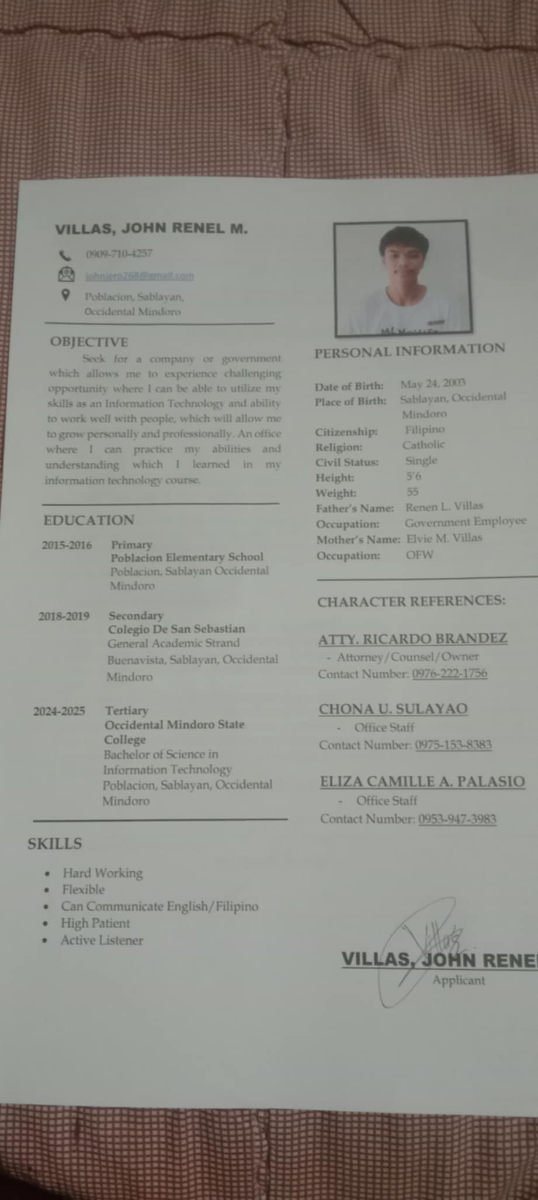**

**APPENDIX “B”**

**ENDORSEMENT LETTER**

**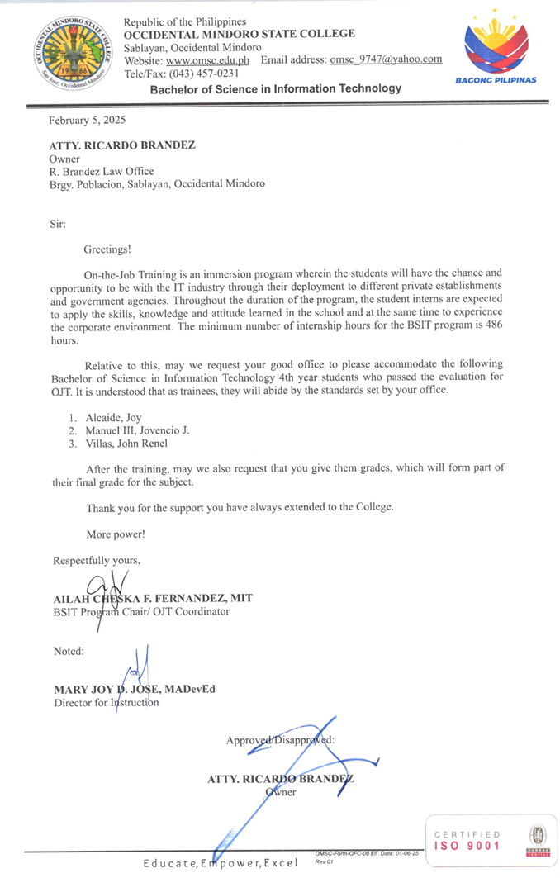**

**APPENDIX “C”**

**Parents’ Consent**

****

**APPENDIX “D”**

**Medical Certificate**

****

**APPENDIX “E”**

**Memorandum of Agreement**

**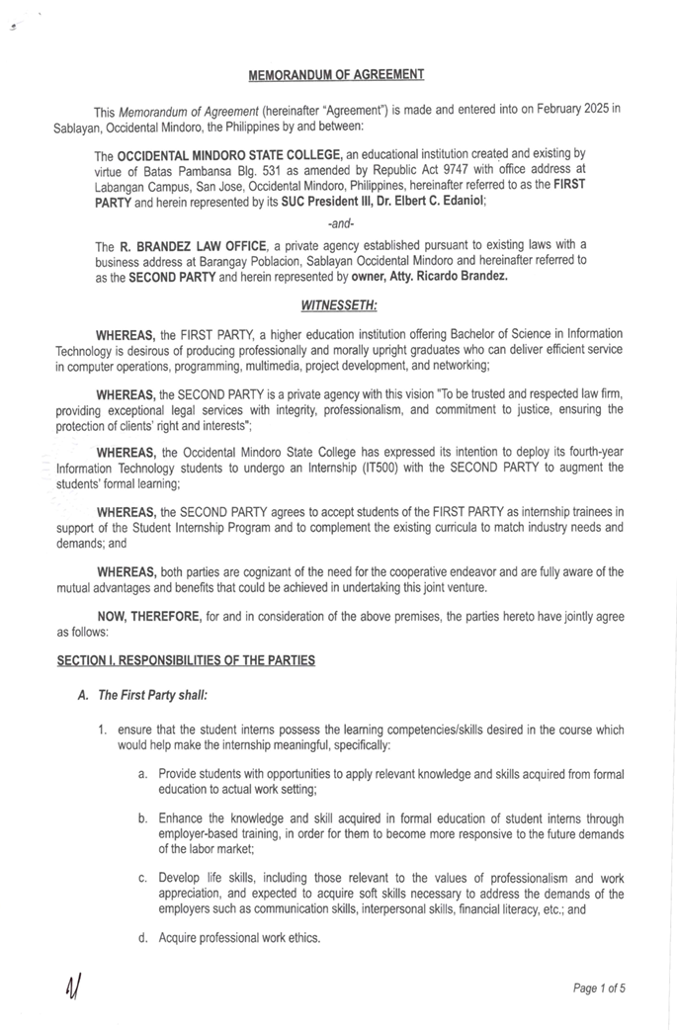**

**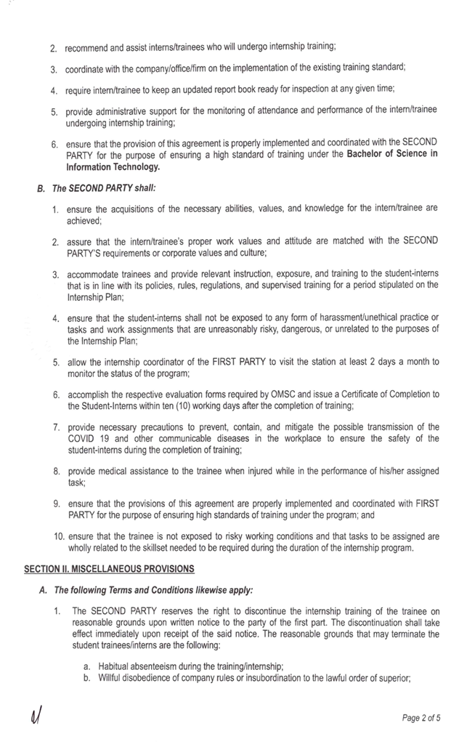**

**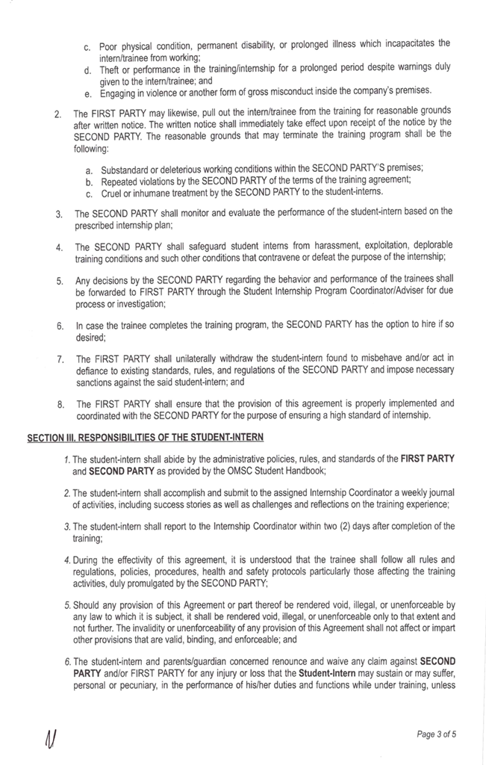**

**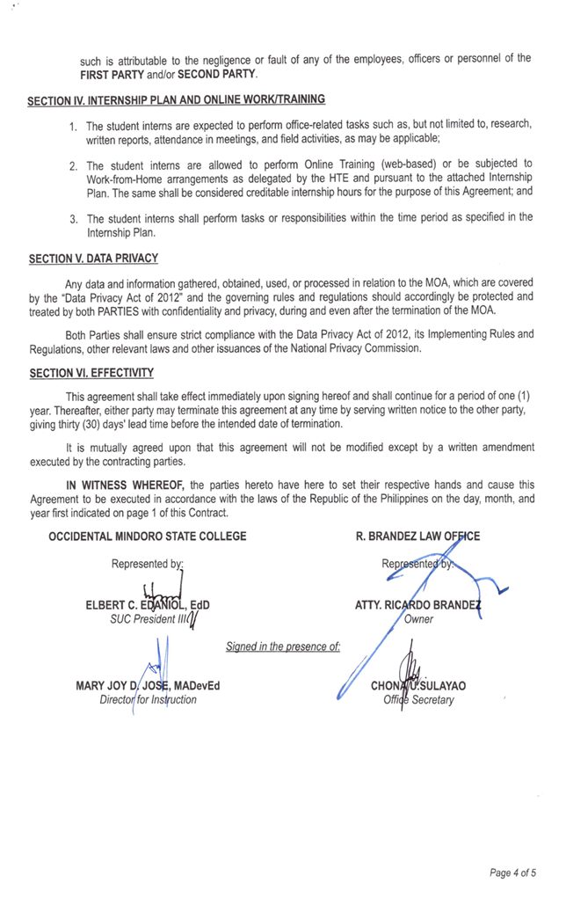**

**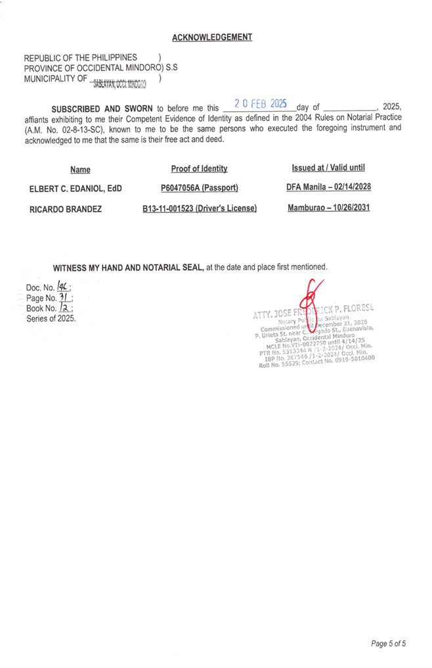**

**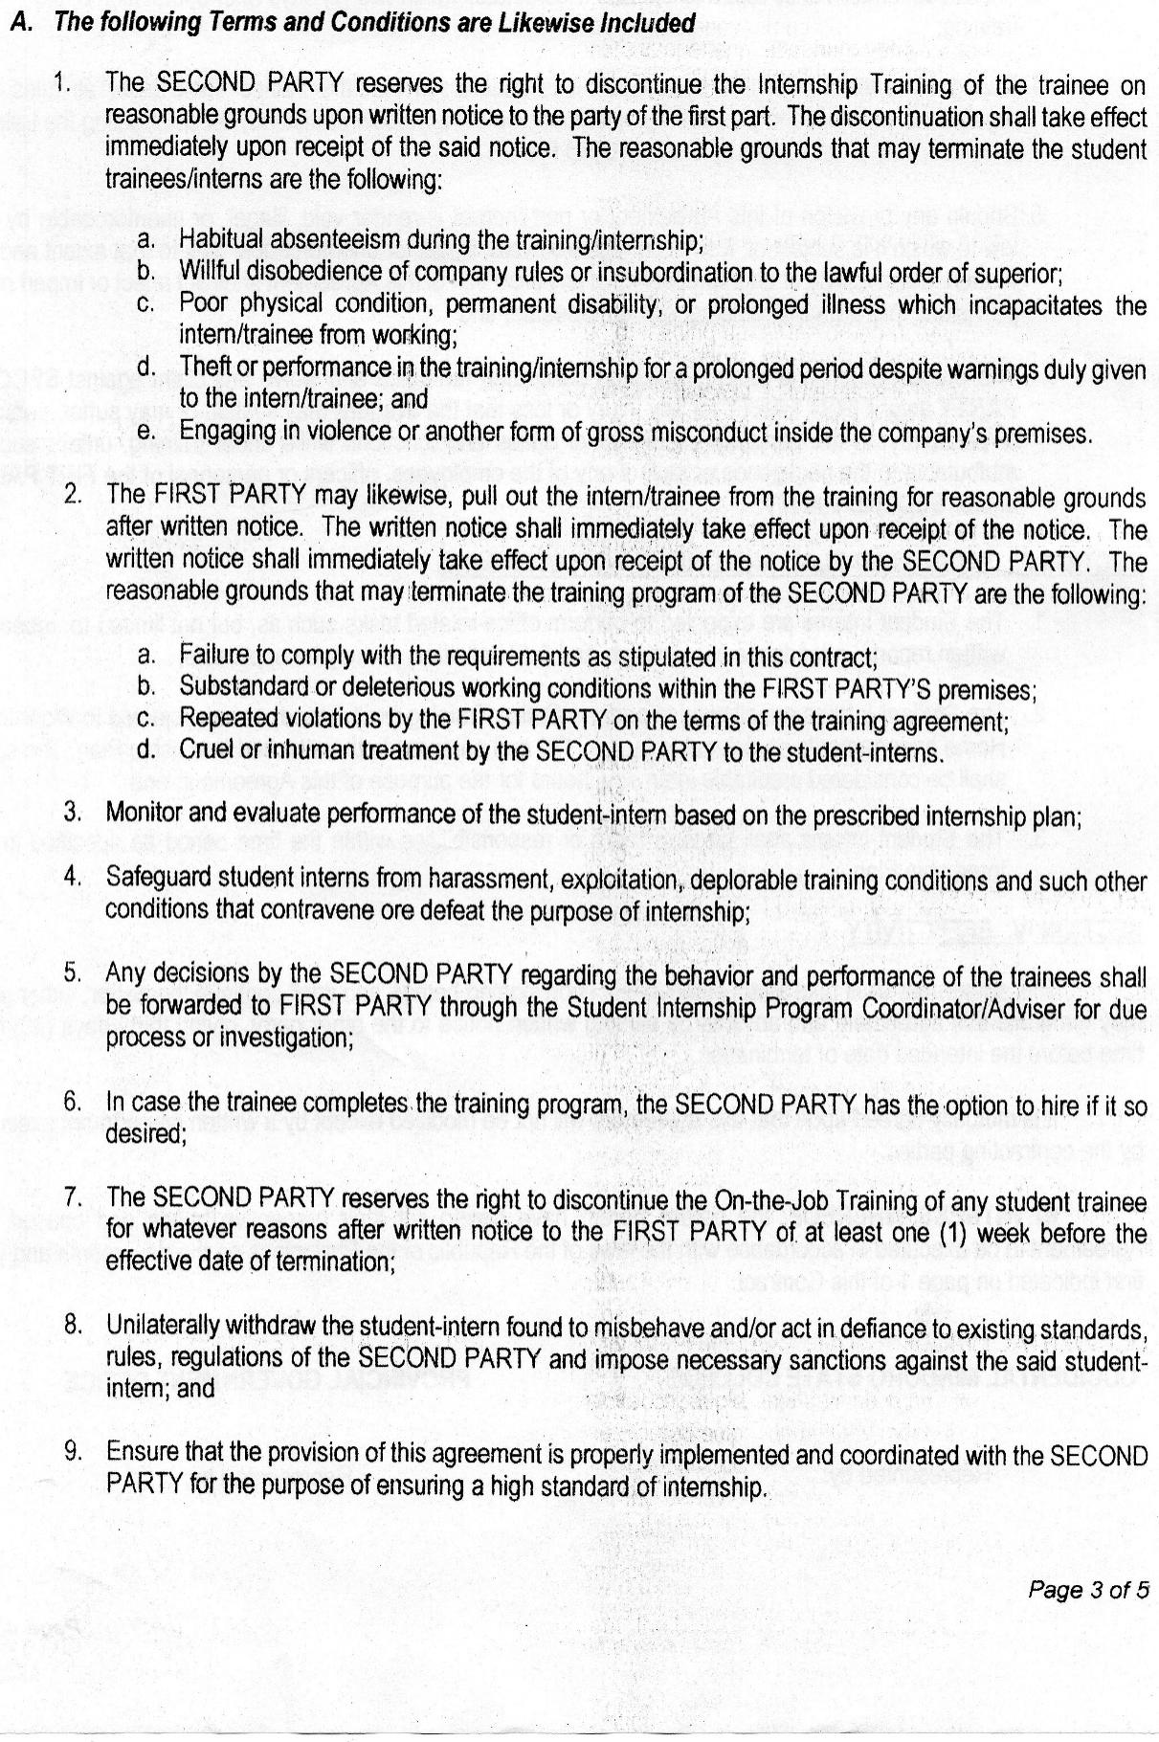**

**APPENDIX “F”**

**SUMMARY OF INTERNSHIP ACTIVITIES**

**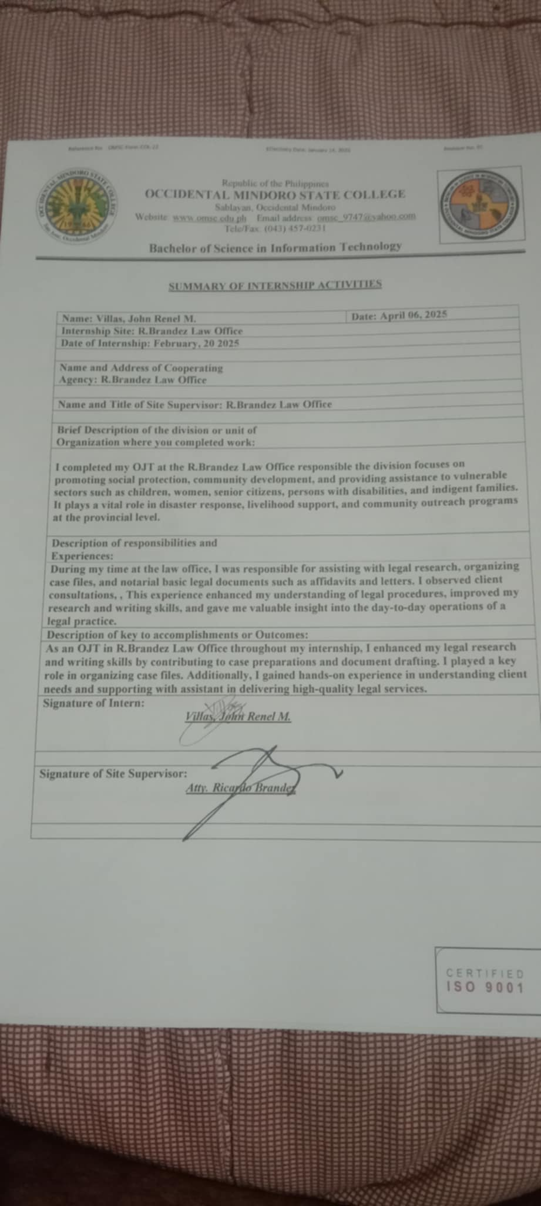**

**APPENDIX “G”**

**INTERNSHIP PROGRESS REPORT**

**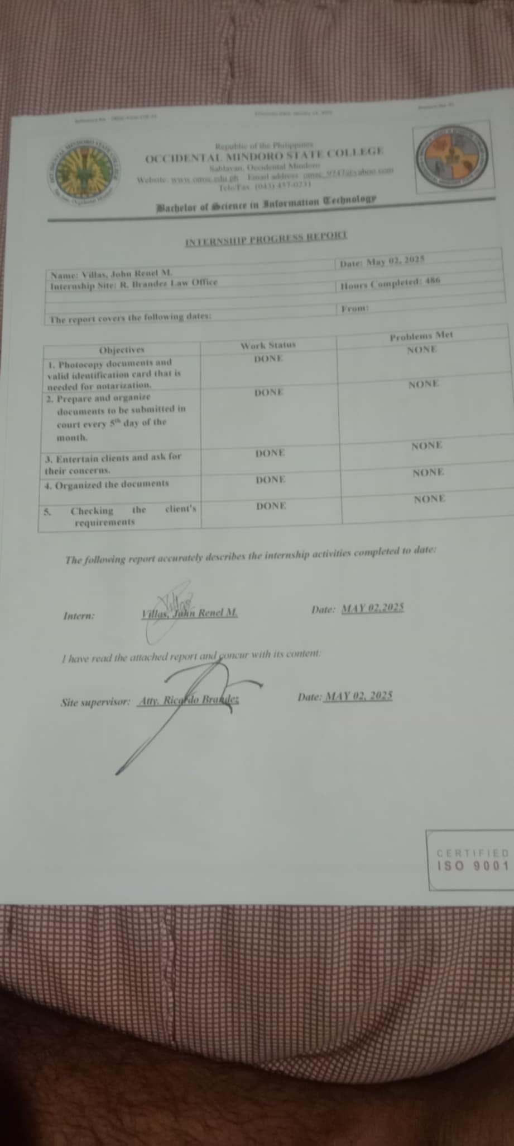**

**APPENDIX “H”**

**INTERNSHIP ANALYSIS REPORT**

**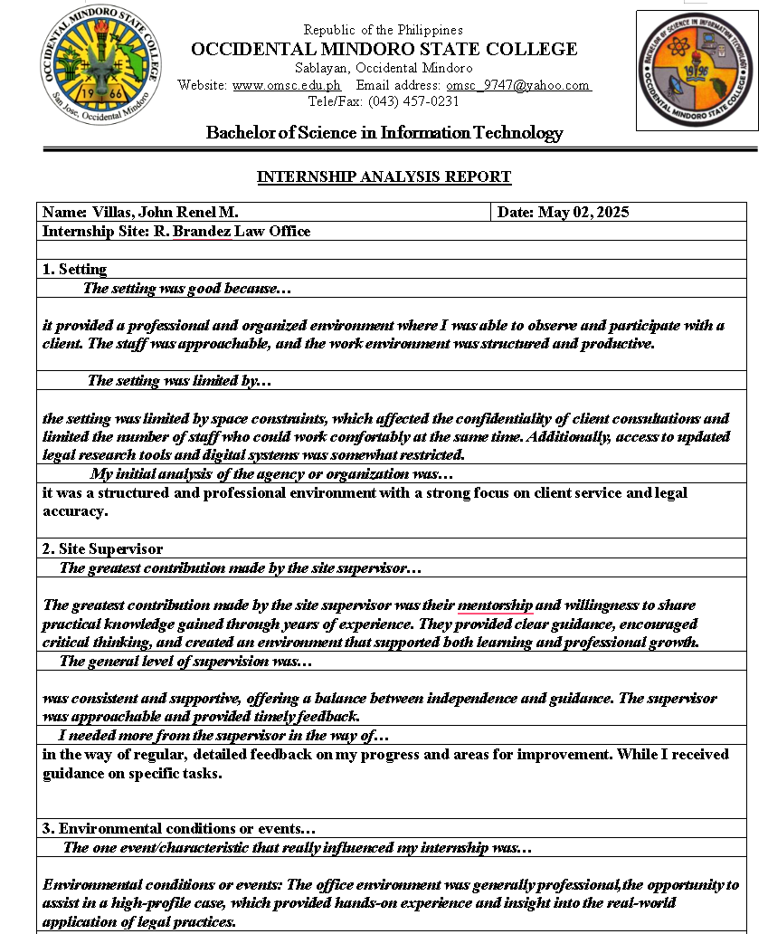**

**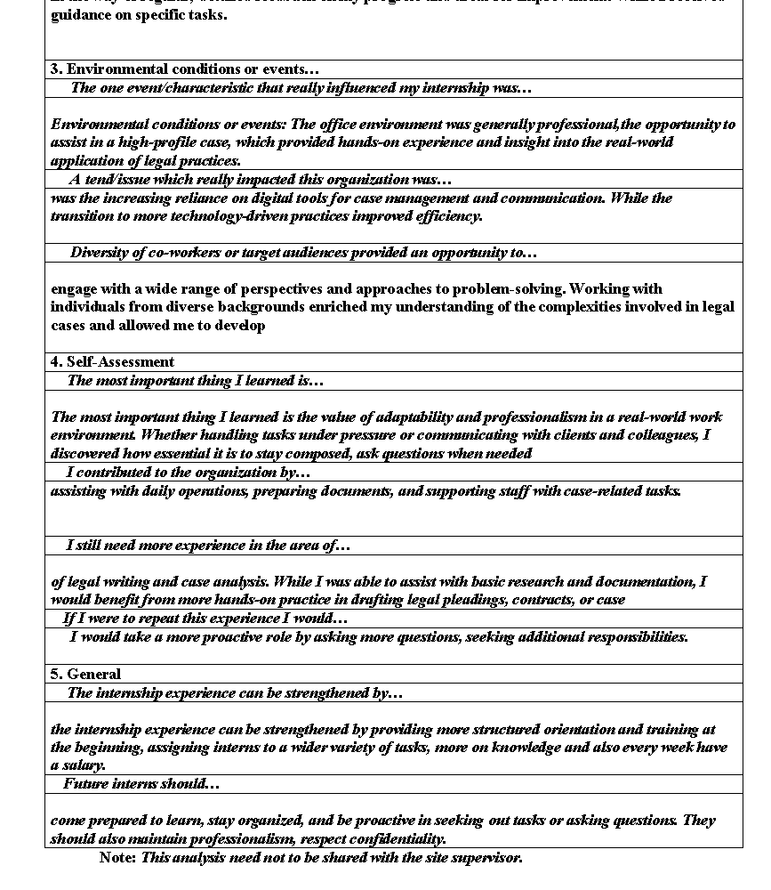**

**APPENDIX “I”**

**DAILY TIME RECORD**

****

****

****

****

**APPENDIX “J”**

**INDIVIDUAL INTERN EVALUATION**

**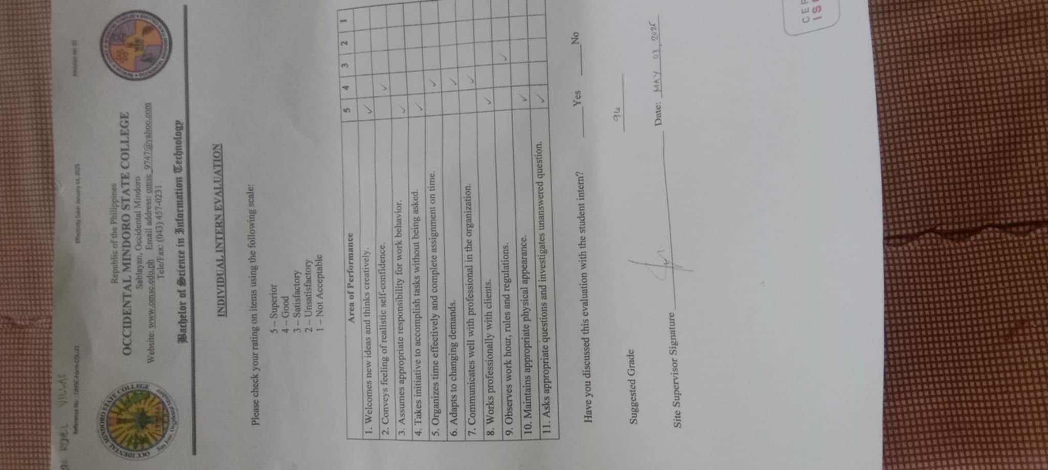**

**APPENDIX “K”**

**COMPANY LOCATION MAP**

**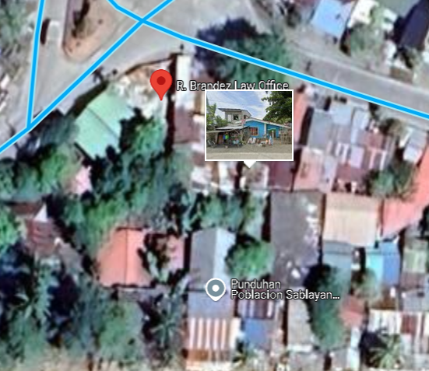APPENDIX “L”**

**On-the-Job (Practicum) PHOTOS**

**PICTURE DOCUMENTATION**

**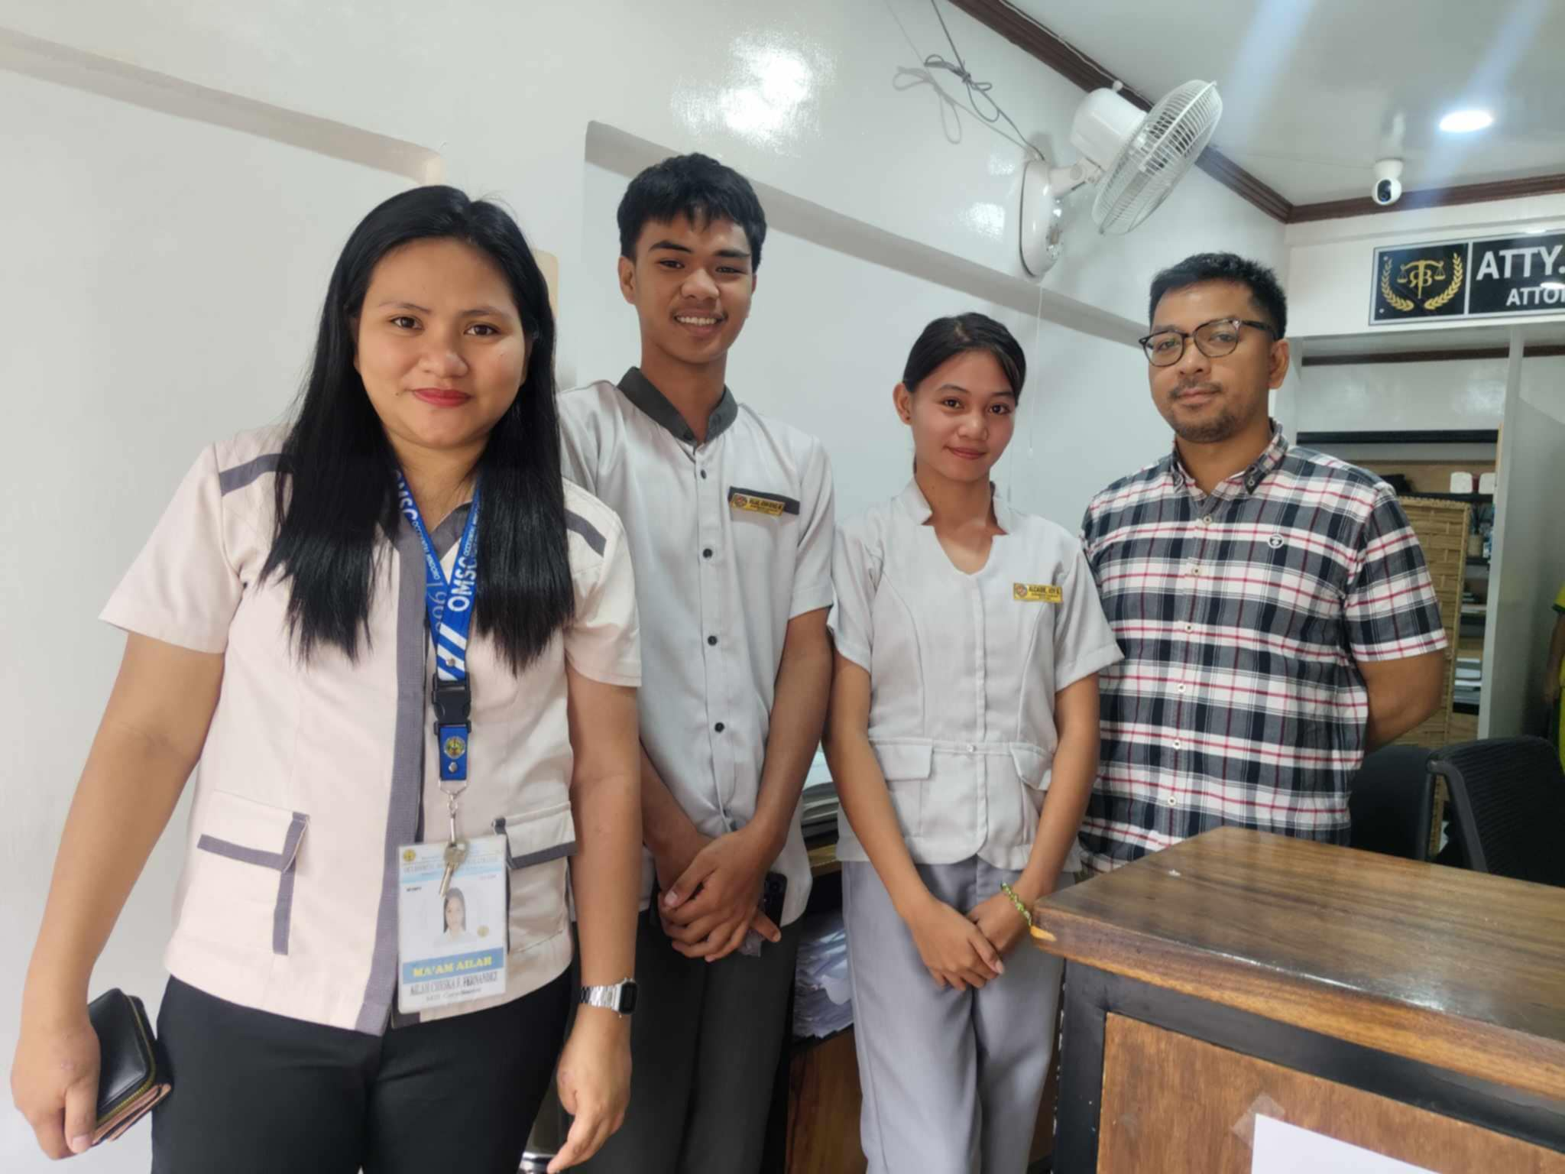**

This was taken during my first day of OJT as I was introduced to Atty. Brandez.

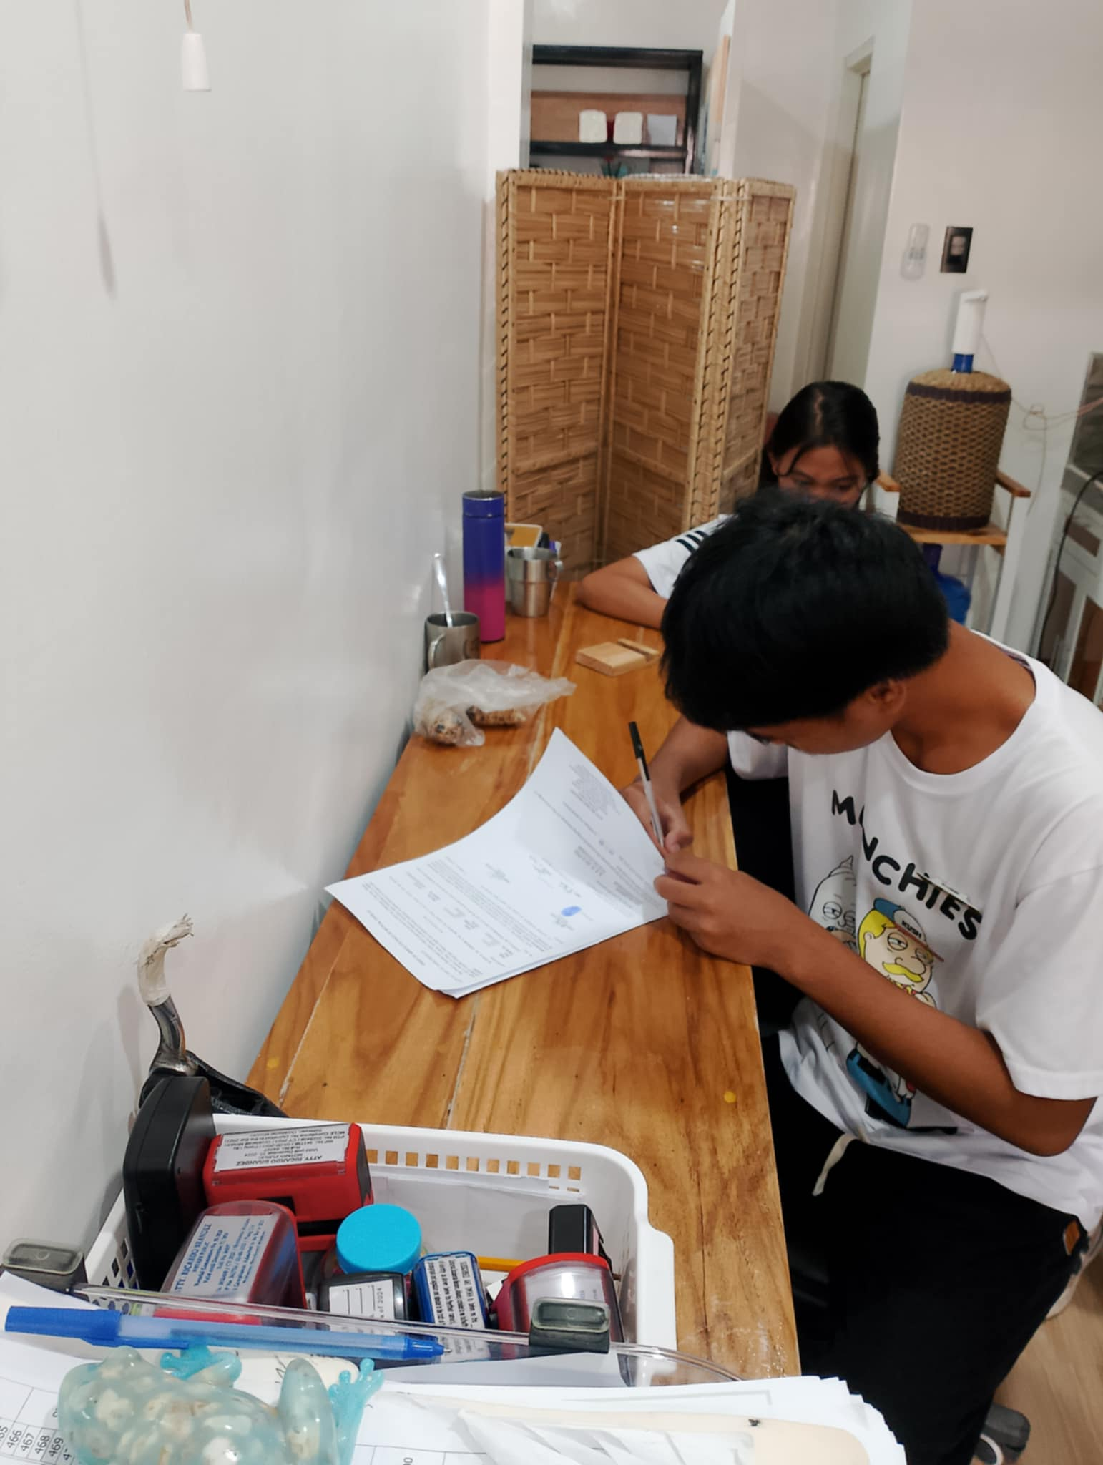

This shows me currently working on the office.

**APPENDIX “M”**

**Softcopy of the Compile Documents**

**APPENDIX “N”**

**Certificate of Completion**

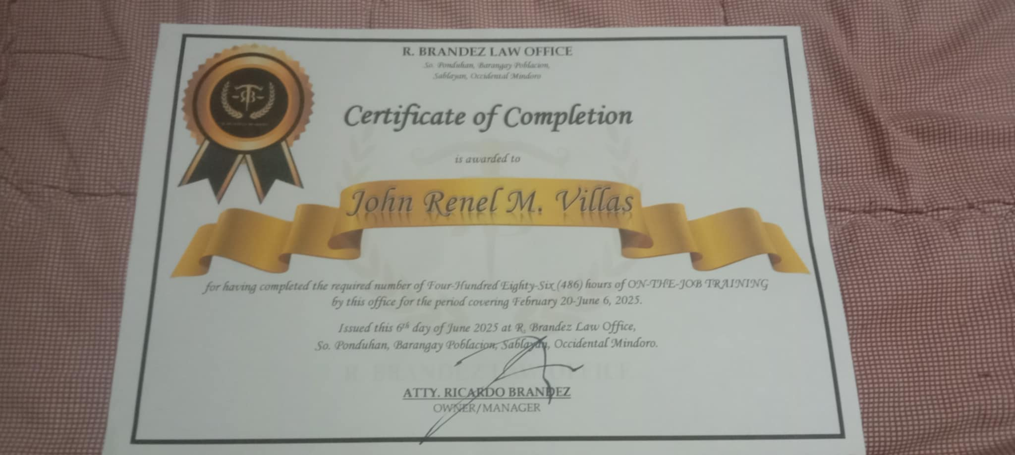

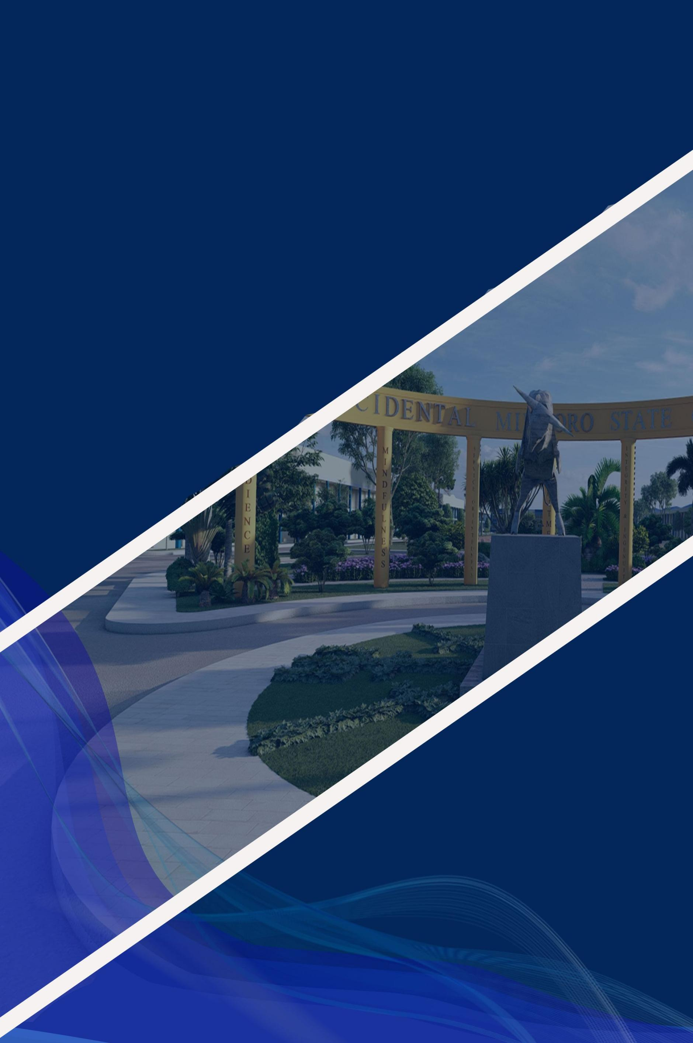

**VISION**

A premier higher education institution that develops locally responsive, globally competitive and innovative professionals and life long learners

**MISSION**

The OMSC is committed to produce intellectual and human capital by developing excellent graduates through outcomes-based instruction, relevant research, responsive technical advisory services, and sustainable production.

**QUALITY**

**POLICY STATEMENT**

The Occidental Mindoro State College is committed to provide quality education and services to its clientele, and to continually improve quality systems, procedures and policies to attain its vision, mission and objectives, and to be responsive to the needs of the stakeholders.

All instruction, research, extension and production activities in the College shall be marked with quality and highest standards of professionalism to ensure optimum customer satisfaction. These activities shall employ with the statutory and regulatory requirements of local and international certifying organization.

The College maintains a culture excellence in every endeavor it undertakes through personnel development and empowerment